**GHANA COMMUNICATION TECHNOLOGY UNIVERSITY (GCTU)**



**FACULTY OF COMPUTING AND IMFORMATION SYSTEMS**

Title:

**DESIGN AND IMPLEMENTATION OF AN ELECTRONIC COMMERCE WEB APPLICATION SYSTEM**

A Project Work Submitted in Partial Fulfillment of the Requirements For

BSc. Information Technology

**BY:**

DANIEL ARKO ADDO

PAUL STEINER TIDINGS

**SUPERVISOR:**

Mr. Frank Boateng

**September 2021**

# DECLARATION

I hereby declare that the project report entitled “E-commerce Web Application for Sales” submitted by Daniel Arko Addo & Paul Steiner Tidings to the Faculty of Computing and Information Systems, Ghana Communication Technology University (GCTU) in partial fulfillment of the requirement for the award of the degree BSc. Information Technology is a record of original work/research carried out by me under the supervision of Mr. Frank Boateng. I further declare that the work reported in this project has not been submitted and will not be submitted, either in part or in full, for the award of any other degree or diploma in this university or any other institute or university.

**DATE:** …………………………

|  |  |  |
| --- | --- | --- |
| **AUTHOR 1:**  PAUL STEINER TIDINGS |  | **SIGNATURE**.................................. |
| **STUDENT ID:** 040917322 |  | **DATE:** …………………...... |

|  |  |  |
| --- | --- | --- |
| **AUTHOR 2:**  DANIEL ARKO ADDO |  | **SIGNATURE**.................................. |
| **STUDENT ID:** O40917135 |  | **DATE:** ……………………… |
| **SUPERVISOR:** MR. FRANK BOATENG |  | **SIGNATURE**.................................. |
| **HOD:** DR WILLIAM BROWN-ACQAYE |  | **SIGNATURE**.................................. |

# ACKNOWLEDGEMENTS

My deepest appreciation goes to God who has supplied all that was once needed to finalize this project and the program for which it was undertaken. There was once by no means a lack or want. Throughout the whole study, He took care of the whole thing that would have stopped us in my tracks and reinforced me even during my most challenging times.

I sincerely acknowledge the contributions of my supervisor Mr. Frank Boateng, from Ghana Communication Technology University (GCTU) whose earnest concern has added the necessary value to this work.

Not a single soul has been more influential to me in the pursuit of this research than the members of my family. I would like to take this opportunity to thank my parents, whose compassion and direction are with me in my pursuit of this program. They are the greatest role models. Most importantly, I wish to thank my friends and course mates who provided unending motivation.

# ABSTRACT

These past two decades, online buying has gained popularity. Despite its ubiquity, online shopping on the African continent is still in its infancy. Moreover, in many African economies, like Ghana, little study has been done on online adoption, particularly among the young, educated customers who make up the largest demographic segment. Our goal is to fill this expanding knowledge vacuum by examining some fundamental characteristics connected with online shopping by young and educated consumers. These characteristics include perceived ease of use, government support infrastructure, pricing, perceived convenience, and use intentions of online retail stores. Finally, our research achievements and future study directions are discussed. Online purchasing has grown in popularity over the last 20 years. Despite its popularity, Africa's use of online shopping lags behind the rest of the world.

Table of Contents

DECLARATION i

ACKNOWLEDGEMENTS ii

ABSTRACT iii

DEFINITION OF TERMS 1

Chapter One: INTRODUCTION 2

Background of Study 2

Problem Definition 2

Aim 3

Objectives 3

Significance of Study 3

Academia 3

Expected Outcomes 4

Scope of the Study 4

Organization of Study 4

Chapter Two: LITERATURE REVIEW 6

Introduction 6

The Six Main Categories of Electronic Commerce 7

Research methodology 8

Classification Framework 9

Case and Applications (CA) 9

Public Policy (PP) 10

Technological Infrastructure (TI) 11

Other Studies (OS) 12

Advantages of E-Commerce 12

Limitations or Challenges of E-Commerce 13

Conclusion 14

Chapter Three: SYSTEM SPECIFICATION AND DESIGN 15

Introduction 15

Agile Software Development Cycle 15

Planning 16

Identifying Problem, Opportunities, and Objectives: 16

Analyzing System Needs: 16

Functionality 17

Functional requirements. 17

Non-functional requirements. 17

Design requirements. 18

Implementation requirements. 18

System Design 18

Use-Case Diagram 19

Admin Activity Diagram 20

Users Activity Diagram 21

Users Sequence Diagram 22

Electronic Commerce Dataflow Diagram 1 23

Electronic Commerce Data Flow Diagram 2 24

System Architecture 25

Implementation 25

System Testing 26

System Maintenance 26

Reasons why Agile Project Management Was Used for This Research 26

Chapter Four: SYSTEM IMPLEMENTATION 29

Introduction 29

Development and Implementation 29

Hardware Prerequisites 29

Software Requirements 29

Testing 30

Implementation of functions 30

Basic HTML of the shop 30

Products in the shop 32

User Registration 34

User Login 35

User Cart 37

User Dashboard and proposed customization 38

The User’s Checkout page 43

The Administrator’s page 44

Chapter Five: CONCLUSION AND RECOMMENDATION 46

Introduction 46

Conclusion 46

Lessons Learnt 46

Recommendations 46

Reference 47

Appendix 48

Hypertext Markup Language Codes 48

Main.html 48

Checkout.html 52

Profile_settings.html 54

Cascading Style Sheet Codes 54

Main.css 54

JavaScript 62

Cart.js 62

Python programming language 63

Admin.py 63

Apps.py 63

filters.py 63

forms.py 64

urls.py 64

Urls.py 64

models.py 65

Utils.py 66

views.py 67

wsgi.py 69

asgi.py 69

settings.py 70

# DEFINITION OF TERMS

|  |  |  |
| --- | --- | --- |
| Term | Full Meaning | Description |
| CSS | Cascading Style Sheets | Describing the presentation of a document written in a markup language. |
| GCTU | Ghana Communication Technology University | a university founded in 2005 by Ghana Telecom, the national telecommunications company |
| HTML | Hypertext Markup Language | A markup language for documents designed to be displayed in a web browser. |
| Js | JavaScript | This is a high-level, interpreted programming language that conforms to the ECMAScript specification. |
| MySQL | My Structured Query Language | An open-source relational database management system |
| SDLC | Systems development life cycle | A term used in information systems to describe a process for planning, creating, testing, and deploying an information system. |

# Chapter One: INTRODUCTION

## Background of Study

Globalization and technology advancements have altered the corporate landscape. Nowadays, many organisations rely on information technology to provide services to customers (Arora & Rahul, 2018; Doolin, Dillon, Thompson & Corner, 2005). Because of the internet and its activities, organisations are putting in efforts and procedures to harness its benefits. Modern internet technology has given clients not just a vast selection of options, but also an integral way of purchasing. Businesses have synchronised strategies to fully benefit from it. One is internet shopping, or selling products and services online (Chang & Wu, 2012; Faqih, 2013; Masoud, 2013).

In addition to the convenience, prior online experiences (Li & Huang, 2009; Tsai & Yeh, 2010), usage usefulness, and other motives such as coverage (Hsieh & Tsao, 2014; Wu & Ke, 2015), online shopping is becoming an increasing phenomenon in the business landscape (Zendehdel & Paim, 2012). In this way, online shopping eliminates geographical constraints. Moreover, enterprises using online platforms may quickly adjust to a customer's preferences (Dillon, Buchanan & Al-Otaibi, 2014), which has been proven to enhance confidence and buy intentions (Tsai & Yeh, 2010). In certain product categories, online buying has become a viable alternative to traditional retail channels (Dillon, et al., 2014).

## Problem Definition

The new generation of buyers turns to the internet first to gather information, compare prices, and order products. Add industry trendsetters like Ikea to the equation, and many buyers no longer feel the need to experience a piece of the item in real life before ordering it. Instead, they count on high-quality product images and customer reviews from their peers. Simultaneously, new e-commerce software technology is raising the bar for customers and professional buyers. Web stores no longer have limitations in how they can display products and variations online, which makes having an online catalog or web store much more appealing. There are also more options when it comes to web store customization. With full (and easy) control over web store look, feel, and functionality, businesses in all parts of the supply chain are warming up to the idea of online sales.

## Aim

This project aims to design an accurate fast and efficient web application system and also to make the suppliers and customers feel comfortable

## Objectives

The specific objectives of the project include:

1. To develop an e-commerce web application system in Ghana.
2. It is a great way for a supplier to grow his or her brand, acquire loyal customers, gain new insights, and get creative with your marketing.
3. Users/Customers get seamless checkout with multiple payment options.
4. Customers can relax at home and make orders that suit their taste rather than roam through the city to find one they are comfortable with.

## Significance of Study

Technology has shown rapid growth in the majority of areas or fields in work and the usage connected to information management. It is very important to know the change in purchasing items and selling items in this modern world, almost everything now is done online. Therefore, this project aims to provide the users of this application to gain comfortability and growth and in selling and buying.

## Academia

The project will provide the chance for fellow students who want to study and analyze the system and improve on it.

## Expected Outcomes

In successful completion of the project the expected outcomes are as follows:

* Users can create accounts that support both sales and purchases of goods.
* Users can send and receive details on products ordered
* Users can decide their mode of payment
* Users can order for more than one product at a time and know the total (Cart).
* Users can update information on their profiles.

## Scope of the Study

The project and research are based on the importance of the online world/ social media as a huge platform and the customer's mind on how the supplier used the English language in the description of the product and how the product was advertised.

## Organization of Study

**Chapter One (1):** The purpose of Chapter One is to introduce the project within the account of the facts relating to the project and detailed consideration of the problem, the aim, and objectives, the significance of the study, and expected outcomes. This chapter presents the justifications behind the idea of the project.

**Chapter Two (2):** Subsequently, Chapter Two focal point is on numerous researches concerning the topic. This chapter provides a contextual review of the current system in addition to the proposed system.

**Chapter Three (3):** Furthermore, Chapter Three describes the system specifications and design of the suggested application. The information system approach is asserted in this chapter and the abstract model for the application is similarly executed at this stage.

**Chapter Four (4):** Then again, Chapter Four places further emphasis on pictorial details regarding the graphical user interfaces of the artifact. This chapter additionally talks about the testing of the system to determine some possible flaws in the application.

**Chapter Five (5):** Finally, Chapter Five puts the topic to a close with the conclusion, summary, and recommendations about the development of the project or the application.

# Chapter Two: LITERATURE REVIEW

## Introduction

Information technologies have had a great impact on the business section of every industry in the world (Kang et. Al. 2016; Corbit et. al. 2003). From teaching to banking to even Agriculture. This is because of the vast usage of data over the years. Not just usage but management as well. Data or information about products, services, or even individuals is recorded or shared each day of our lives. With the advancement of information technologies, Electronic commerce got introduced and it has attracted the interest of many businesses. Whether small businesses or big ones. Most businesses have already made it a priority to have their business transactions done through Electronic Commerce(E-Commerce). One will ask, “What is the definition of E-Commerce?”

Electronic Commerce, also known as E-commerce, doesn’t have a generally agreed definition. However, the definitions that will be used here are those given by Kalakota and Whinston under specific perspectives.

1. From a communications perspective: E-Commerce is the delivery of information, products/services, or payments via telephone lines, computer networks, or any other means.
2. From a business process perspective, E-Commerce is the application of technology toward the automation of business transactions and workflow.
3. From a service perspective, E-Commerce is a tool that addresses the desire of firms, consumers, and management to cut service costs while improving the quality of goods and increasing the speed of service delivery.
4. From an online perspective, E-Commerce provides the capability of buying and selling products and information on the Internet and other online services.

The application of electronic commerce has been seen in many fields over the years such as inter-organizational systems (IOS), electronic payment systems (EPS), financial services, retailing, auctions, education and training, marketing, and advertising, and other applications.

Many businesses and companies have seen the advantages and impact of Electronic Commerce and have decided to join the Electronic Business(E-business) commercial industry. The International Business Machines Corporation, commonly known as IBM, was the first to use the term E-business in October 1997 as a campaign related to E-business was launched by them. One popular company that has shown the advantage of electronic commerce over the years is Amazon.com. Over a decade of 2001 to 2006, Amazon.com saw a rise in their profit from $2.5billion to $61billion.

Many scholars from various disciplines have questioned why consumers choose to purchase online, how much faith they place in online stores, and what this trust is based on (Chaparro-Peláez et al., 2016).

This Literature review comprises Six sections. In the first section, the research methodology is explained along with more emphasis on the definitions related to Electronic Commerce. In the second section, the six main categories of electronic commerce are identified. For the third section, to categorize the studies, we build a classification framework and further describe these categories. In the fourth section, some of the popular advantages of Electronic Commerce are emphasized. In the fifth section, the challenged and limitations to which the Electronic Commerce world meets are also identified. The last section, which is the sixth section, concludes and emphasizes the most important findings.

## The Six Main Categories of Electronic Commerce

E-commerce benefits three stalk holders. Namely; The business, individuals, and society. Due to this, E-commerce can be divided into six main categories: Business-to-Business(B2B), Business-to-Consumer(B2C), Consumer-to-Business(C2B), Consumer-to-Consumer(C2C), Business-to-Administration (B2A) and Consumer-to-Administration (C2A).

**Business-to-Business (B2B**) is an electronic means of carrying out business transactions between two or more businesses.

**Business-to-Customer (B2C)** is an electronic means of carrying out business transactions where companies sell directly to customers thereby reducing the number of intermediaries so they can achieve higher profits while charging lower prices.

**Customer-to-Business (C2B)** is an electronic means of carrying out business transactions where the customer or consumer is now the seller of the products and the company or business is now the buyer. With this, the business buys the products made available by the customer to accomplish their business process.

**Customer-to-Customer (C2C)** is an electronic means of carrying out business transactions whereby the customers make trades with each other and this is commonly seen with companies such as eBay.

**Business-to-Administration (B2A)** is an electronic means of carrying out business transactions that involve all the transactions that are carried out between businesses and government bodies.

**Consumer-to-Administration (C2A)** is an electronic means of carrying out business transactions that involve all the transactions that are carried out between consumers and government bodies.

For a successful Electronic business, one must under the limitations and minimize the negative impact it could have on the business but at the same time, try as much as possible to maximize the benefits.

## Research methodology

This survey was created by connecting and reviewing journals. We did not add the master's theses, textbooks, etc. So, therefore, we have concluded that researchers and academics also use journals to gain knowledge and present them in a very fine manner. All the articles that were reviewed were connected to E-commerce (EC). The literature review gained 257 articles which were written in 10 journals. The journals were chosen as outlets for E-commerce research.

Nowadays it is now clear that E-commerce cannot be brought down in one zone because of research interests in E-commerce like the application areas and public policy. Now, EC education is verified in several journals by researchers by people with different contents. For example, while some researches are made by people who have engineering disciplines and are mostly focused on the technological side of it and also people made researches with social discipline deal with the public policy parts of the EC such as trust, etc. For this reason, several databases which include publications such as "ABI Complete, Taylor & Francis Online Journals were reviewed.

Articles that have been verified in Journals and papers were taken into account in this final literature review. Master's and doctoral theses, the verification of the books and articles have not ended were excluded. This research was performed using "E-commerce" "Electronic business" and "internet commerce" words.

## Classification Framework

This is the type of framework which is gained from literature review, the knowledge which is also gained from classification schemes of Ngai and Wat (2002) and Turban et al. 2000 and many other amazing schemes made and constructed for Information Systems in the studies Alavi and Carlson, (1992) and Barki, et al. (1993). E-Commerce literature is divided into 4 main sections which are, Case and Applications, Technological Infrastructure, Public Policy, and Others.

### Case and Applications (CA)

Case and applications sections consist of payment systems, intra-organizational applications, training, advertising, retailing, financial services sub-categories.

* Payment Systems (PS)

Electronic payment (EP) is often used as a method of payment online. There are a lot of ways in which payment online can be made and these are online credit card transactions, electronic wallets, electronic cash, online stored value systems. (Treiblmaier et al. 2006; Junadi and Sfenrianto 2015).

* Inter-organizational Applications (IOA)

This includes applications developed in collaboration with multiple business partners, such as electronic data interchange, electronic funds transfer, and supply chain management (Ngai and Wat 2002).

* Training (TR)

This topic is about EC in the field of education and training, like publishing and selling academic documents such as articles, books, and so on, as well as virtual classroom technologies.

* Advertising (AD)

This includes advertising applications so-called online advertising in EC. Online advertising, is a form of marketing and advertising which uses the internet to deliver promotional marketing messages to consumers. It includes email, search engines, and social media marketing.

* Retailing (RE)

This section contains literature on internet shopping applications. Many items, including consumer electronics, office furniture, sporting goods, jewelry, and automobiles, can be sold via e-commerce over the Internet.

* Financial Services (FS)

This section contains research on internet payment services such as Online banking, also known as virtual banking, online stock exchange, and online insurance. Aside from these, nearly all payments and transactions can now be performed via the Internet.

### Public Policy (PP)

This main component is divided into 4 subcategories: confidence, theft, income tax, and legal issues.

* Trust (TS)

One of the most interesting posts analyzed in EC studies is trust. Most of the other core subjects include purchase intention assessment of trust, as well as factors influencing credibility.

* Loyalty (LO)

This section contains journal articles on customer loyalty in EC studies. Loyalty in EC, however, according to Srinivasan et al. 2002, is a consumer's favorable attitude toward the electronic seller that leads to repeat purchasing behavior.

* Legal Issues (LI)

This topic is made up of legal rules and regs literature, which is yet another very important problem in EC. Because the EC is not restricted or governed by any defined by any laws or regulated by a single government entity, it has created some uncertainty about whether states and local governments have a legal right to claim custom duties. Authorities are eager to add their legislation in traditional methods or expand the scope of their legal authority.

### Technological Infrastructure (TI)

This main topic's subtopics are protection, software applications, technical advice, and systematic research.

* Security (SE)

Customers' primary reasons for not purchasing over the Internet are privacy and security concerns. Data security is defined as the protection of data from unauthorized disclosure, modification, or destruction, whether accidental or intentional (Udo 2001). This chapter covers literature on security issues such as secure sockets layer, secure electronic transactions, and so on.

* Support Systems (SS)

This subcategory includes management information systems including, decision-making systems and panel data modeling, as well as their systems on EC such as website evaluation and improving electronic business.

* Methodological Research (MR)

This topic includes articles that have been published about techniques and algorithms that have been proposed to improve the effectiveness and protection of EC apps.

### Other Studies (OS)

This category includes detailed information and the establishment of EC literature.

## Advantages of E-Commerce

1. Faster buying process

Customers can save time when shopping for what they want. They can simply navigate through a large number of items at once and purchase whatever they like. Customers can find items that are available in physical stores much further away from them or that are not available in the community when they shop online.

1. Cost reduction

Cost reduction is one of the most important benefits of e-commerce to businesses that keep sellers involved in online business. Many sellers must pay a lot of money to keep their physical store open. They may have to pay additional upfront costs such as rent, renovations, interior design, inventory, and so on. In several cases, though after investing in services, inventory, general upkeep, and labor, sellers do not receive the expected profits.

1. Affordable advertising and marketing

Sellers do not need to spend a lot of money on advertising their products. There are several inexpensive and quick ways to market online in the world of e-commerce. Sellers can indeed display their goods on e-commerce marketplaces because they are visual pathways. Amazon sellers, for example, can use Advertising tools to include videos, visualizations, and high-resolution images.

1. Flexibility for Customers

One significant advantage of e-commerce for businesses is the ability of sellers to give flexibility to customers. One notable feature is that the product/service is available 24 hours a day, seven days a week. As a result, the seller can offer his item at whatever time and from any location.

1. Product and Price Comparison

Sellers in e-commerce can compare products using tools or on their own. It, therefore, provides them with a great option if the product options are available, as well as the daily rates, if a product need is not met.

## Limitations or Challenges of E-Commerce

Although E-commerce has great advantages and all, it also has its downside just like every other program. The following are the Limitations or Challenges of E-commerce.

1. Security

The most serious disadvantage of e-commerce is the protection of information. People are hesitant to provide personal and sensitive details, despite recent advancements in data encryption. Definite websites lack the power to undertake genuine transactions. The fear of giving out credit card details, as well as the risk of fraudulent activity, are limiting the development of e-commerce.

1. Tax issue

Whenever the buyer and seller are in separate states, sales tax becomes an even bigger issue. When another buyer and seller are in different states, calculating sales tax can be difficult. An even worse factor here is if web transactions are tax-free, physical stores will suffer a loss of business.

1. Fear

People are afraid of operating in a paperless, faceless electronic world. Some businesses today don't even have a physical presence, and people have no idea of who they are conducting business transactions with. This factor encourages people to make purchases in physical stores.

1. Product Stability

To buy products, people must rely on online photos. When the products arrive, they may or may not match the online photos. Finally, this may not meet the requirements of the buyers. People avoid e-commerce due to a lack of "touch and feel."

1. High Labor Cost

The organization's websites must be developed and managed by a highly skilled and technically qualified workforce. Because the internet offers a plethora of employment opportunities, businesses must incur significant costs to retain a talented number of workers.

## Conclusion

The advantages of E-commerce are very many and they suppress the disadvantages even though they also exist. There are, around clock availability, easy and fast access, a wider selection of goods and services, and international reach which makes it one of the extraordinary economic development of the 21st Century. Although it sounds all good, it has its disadvantages too like every other thing. These are, not being able to feel the product before buying it, most people love to touch the item they are buying before purchasing it to know if it is original or fake.

E-commerce subjects and contents are so broad that they are dispersed across various journals and databases. In this document, the classification framework is comprised of four main and fourteen subfields is presented and eventually, E-commerce literature is evaluated and classified following this framework. According to the results of research, the amount of E-commerce studies will rise at a rapid pace.

# Chapter Three: SYSTEM SPECIFICATION AND DESIGN

## Introduction

In this phase, we will concentrate on the methodology, which is widely used here in this study. It describes the application's design, the programming procedure to be used, the development steps, and the hardware and software requirements that would be used in the project's design. In this growth of the project, we shall use the Agile Software Development Cycle, knowing that the project will be successful and will be finished on time.

## Agile Software Development Cycle

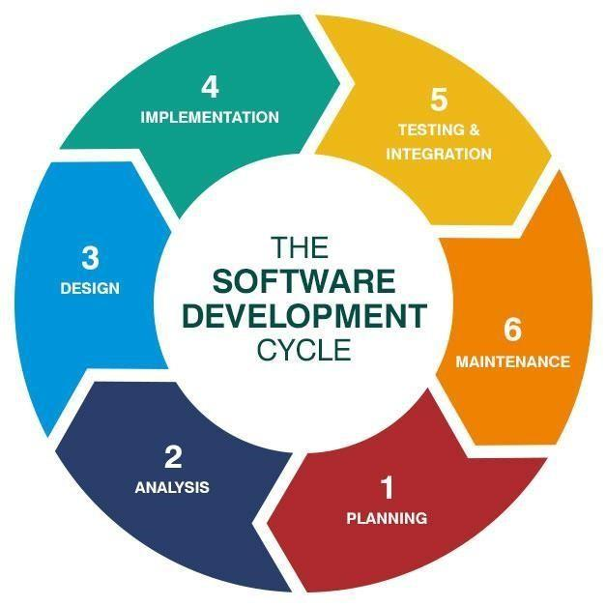

Figure 3.1

Source: Datarob, 2019

Agile software development is a catch-all term for a variety of traditional software development techniques such as Extreme Programming, Scrum, Dynamic Systems Development Method (DSDM), and others. Agile development is more than just sprints, daily scrum meetings, pair programming, and test-driven growth. Its methodologies all essentially combine iteration. Under the SDC which is the Software, development cycle shows how all projects are created or made

## Planning

### Identifying Problem, Opportunities, and Objectives:

Because the planning phase is the first stage in the Software Development Life Cycle (SDLC), it is seen as the most important step in creating a successful system. During this stage, the developer decides what needs to be done and how to fix the problems. These are some examples:

* Problems and Goals will be identified
* Developing the ability to suggest alternative solutions after meeting with students and staff.
* Finding new ways to make a new web application for e-commerce that will be much better than the old ones

Following an examination of the obtained data, the developer must choose one of three options: build a new web application, improve upon the present web application, or leave the state as is.

## Analyzing System Needs:

This step entails recording the assessed and decided buyers' and sellers' needs and requirements. Throughout this stage, the end expectations of user's for the system and its operation is identified. On top of that, a feasibility analysis will be performed to determine whether the idea is socially, commercially, and organizationally viable. Maintaining a high degree of contact with the users ensures a clear picture of the completed artifact and its usefulness. This procedure provides answers to a variety of questions about the business environment, including;

* What steps must be taken to make the web application for e-commerce more understandable?
* How could the new approach be designed to be user-friendly?
* How could the system benefit the participants? Will the system be more accommodating?

### Functionality

The technology will engage with the user by coordinating their activities and simplifying the approval process. The interaction takes place online, using a computer web browser.

The information included in a customer's table in the database will allow them to log into the system. This data aids in the smooth running of the system. Customers will be able to view their profiles, make purchasing requests to various sellers, and check the progress of their requests. The information of Sellers and Buyers from different countries will be kept in the database.

* Users
* Buyers
* Sellers

### Functional requirements.

1. The system will have an enhanced shopping cart that is, such things as lengthy checking out processes, the security-related issue will be avoided.
2. The system will also have a customizable theme. Not everyone prefers the default theme that the system offers so therefore, this will be applied.
3. The system will again have a content management system. Buyers love to see something written about the product before buying it from the Seller.

### Non-functional requirements.

1. Privacy is an important requirement in E-commerce. Everyone in electronic commerce needs privacy to feel safe so therefore this will be applied.
2. The performance of the system will be ensured that is, during the time at which lots of traffic occur in the system, it would not slow down for anyone.

### Design requirements.

The system must work in the form of an online web application. It will keep records of the buyers and the sellers, including the transactions.

### Implementation requirements.

This system must be implemented in Python Django Framework. The presentation layer of this system must be implemented in Hyper-Text Markup Language, Cascading Style Sheet, JavaScript, Django framework and Python Programming Language. The database to be used will be MYSQL

## System Design

"Systems design specifies system elements like as architecture, components, modules, interfaces, and data for the system to meet stated criteria" (Roohi Chhabra 2018). It is a way of graphically developing systems to meet a specific need and requirement of an organization.

This step follows a thorough analysis of the customer's needs. The purpose of general system design is to determine the conceptual perspective of the system and its function. A comprehensive and developed system design that physically and logically meets all functional and technological criteria is established.

These designs are created using graphical modeling languages such as:

1. Data Flow Diagram; a method of depicting the flow of a process
2. System Architecture Diagram; This is used to illustrate the relationship between several components
3. Use Case Diagram; to show the interactions between the components of the system
4. Sequence Diagram; to show the interactions of things at a certain time.
5. Entity Relation Diagram; is used to specify the relationships that exist between entities.
6. Activity diagram; flowchart to represent the flow from one activity to another activity.

## Use-Case Diagram

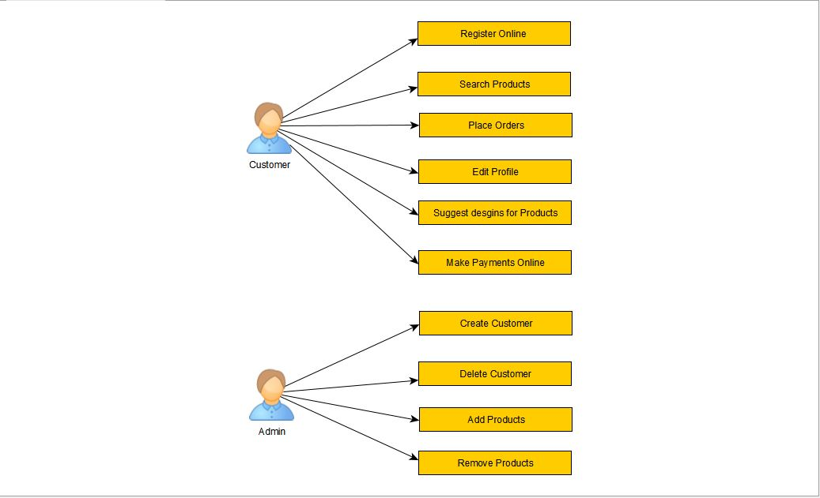

Figure 3.2

Source: Authors, 2021

Use-Case Diagram showing the relationship between the System, User, and Admin.

## Admin Activity Diagram

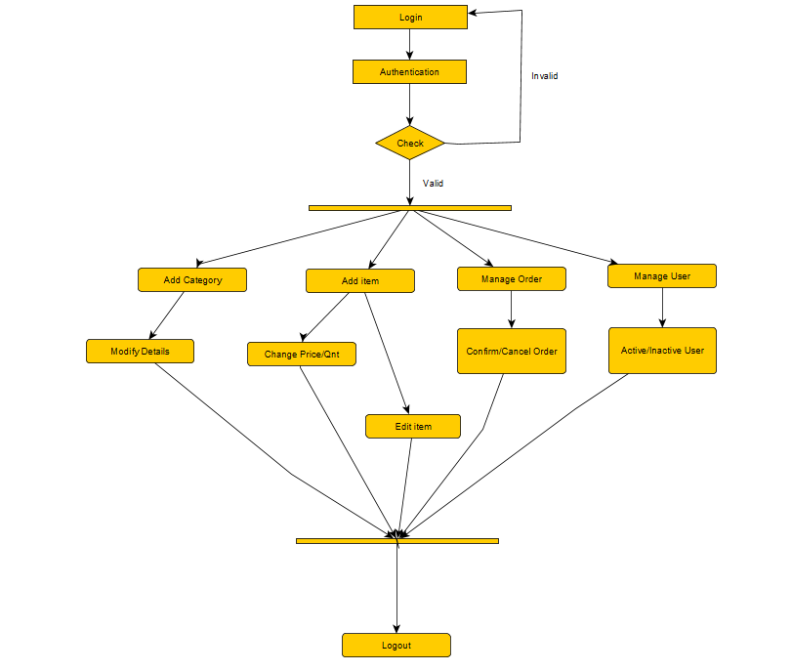

Figure 3.3

Source: Authors, 2021

The process of activities performed by the admin operator when using the system is depicted in the diagram above.

## Users Activity Diagram

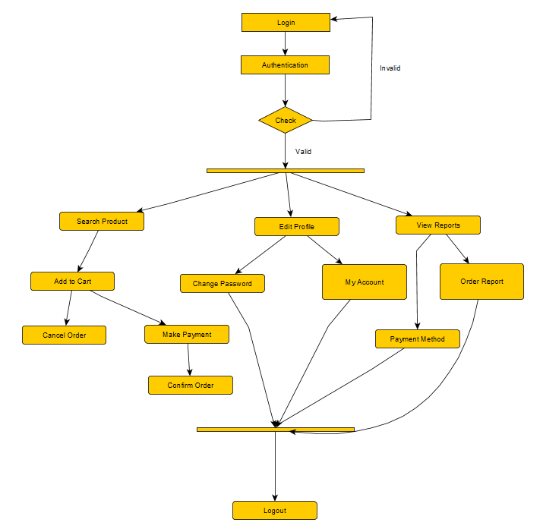

Figure 3.4

Source: Authors, 2021

The above graphic depicts the activities taken by Users (Buyers) when using the system

## **Users Sequence Diagram**

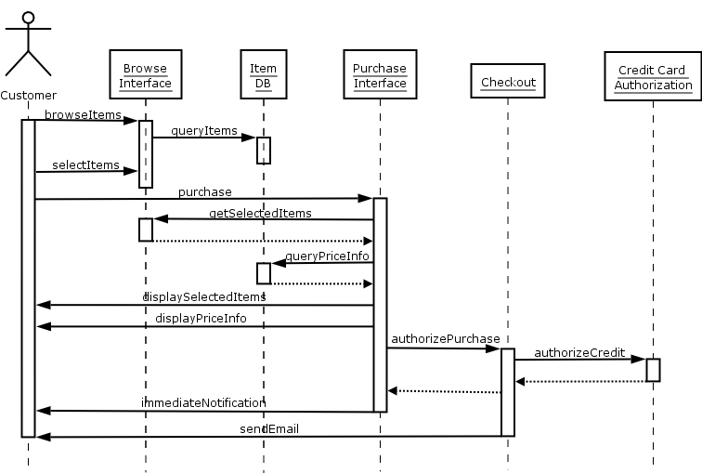

Figure 3.5

Source: Rabi Prasad Padhy and Manas Ranjan Patra, 2021

The user's sequence diagram shows how the users interact with the system.

## Electronic Commerce Dataflow Diagram 1

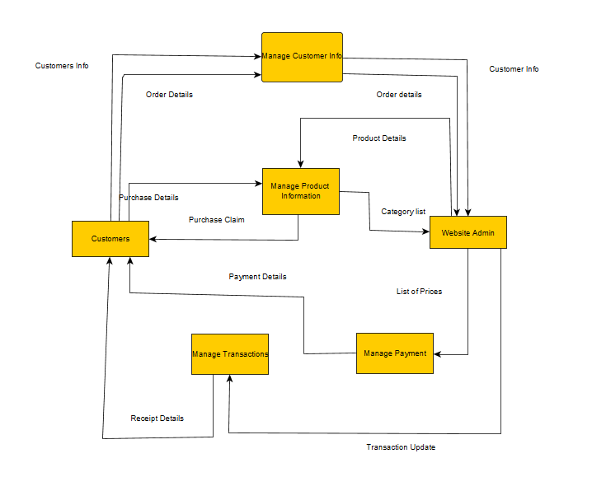

Figure 3.6

Source: Authors, 2021

The diagram above displays the flow of processes that goes on in electronic commerce.

## Electronic Commerce Data Flow Diagram 2

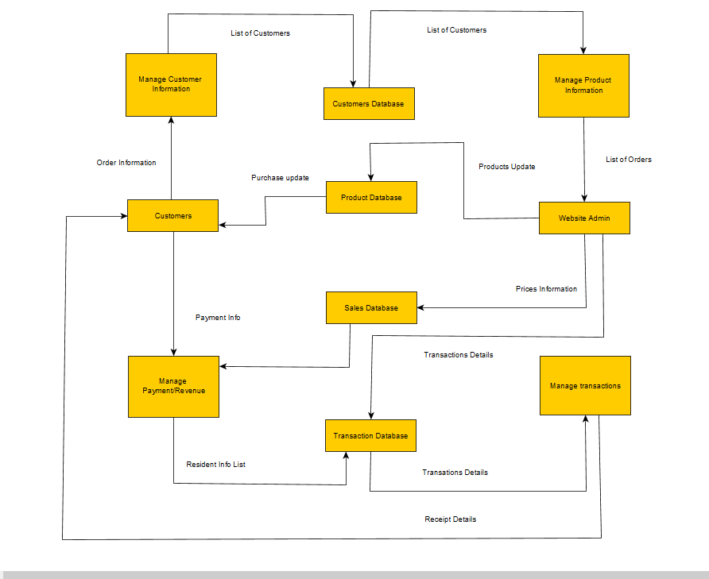

Figure 3.7

Source: Authors, 2021

The diagram above displays the flow of processes in electronic commerce.

## System Architecture

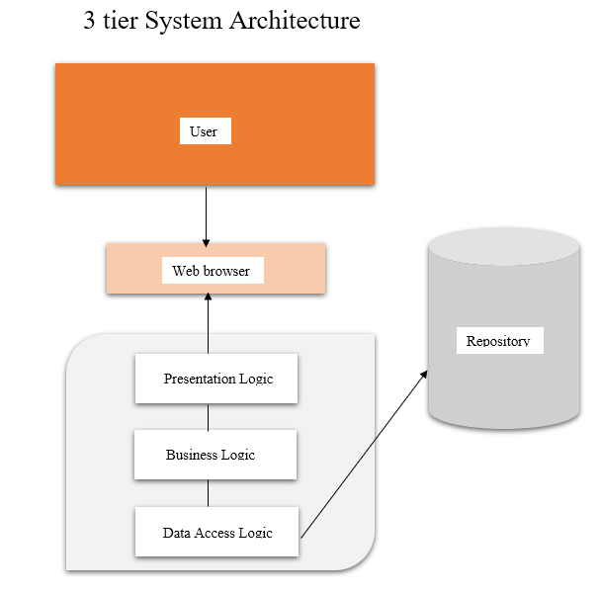

Figure 3.8

Source: Authors, 2021

The architecture of the system shows how the fundamental structure of how electronic commerce will function

**The presentation logic** is in charge of delivering and preparing data to the application for additional processing or presentation.

**Business logic**: The component of the program that encodes the legitimate business rules that define how data may be generated, presented, saved, and modified.

**Data Access Logic**: This is used to access and communicate back and forth through your database & your app.

## Implementation

Following a thorough understanding of the system requirement specification, the development of the system required for approval will begin in this phase. This is the stage at which the actual web-based clearing system is built after the system's design has been completed and described. Throughout this stage, genuine programs are being written to meet several criteria that were discovered during the early stages. The time of the implementation cycle will differ accordingly to the system and the answer it provides.

## System Testing

This is the final level of the SDLC, excluding one. During this stage, all of the subsystems and components are combined to form a fully integrated web application system. The system will next be exposed to a variety of inputs to acquire and assess its outputs, actions, and functions. Because customer happiness must be assured, testing will become increasingly important. Because this technique requires no coding knowledge, consumers may test the finished output. The analysis will be conducted in an orderly and automated fashion to check the actual results as they are related to the expected and intended outcomes.

## System Maintenance

This is the SDLC's last step, which includes cyclic care to validate the system and eliminate obsolescence. This involves a constant review of system performance using new technologies to combat current security risks, as well as the deletion and insertion of codes to offer standardized updates.

## Reasons why Agile Project Management Was Used for This Research

Agile is ideal for any project that has several versions that must be evaluated and improved upon before the outcome is ready for release. For example, instead of waiting 6 months for a delivery that is either faulty or no longer meets the current needs, Agile allows or gives the developer a chance to produce the prototype within at least two weeks (or less) for fast inspection and feedback and so we can keep on improving every single time until it is complete. These are the main reasons why we chose Agile Software development lifecycle;

1. Incorrect approaches to developing the system are quickly identified

It is written when a developer takes a wrong path it is very difficult to correct them later, this is well known by developers around the world.

1. Change is recognized as inevitable and is embraced

Many developers are well aware that no one can describe exactly how a system should function at the outset of a project. Because of the need to get the requirements perfect before going on, many waterfall projects suffer from "analysis paralysis." The system is created continuously with agile, and course adjustments are performed along the way.

1. The final product contains the most useful features

This is because the project is involved in the product's lifecycle, it is effective at finding activities that improve value. Identifying all of the needs at the outset of the project, on the other hand, may result in the technology being created that has minimal or no value in operation.

1. The technical documentation takes less time and is correct

This is because the documentation is restricted to the artifacts required to complete the task (user stories, test cases, and so on), it represents what was created rather than what may have been intended. Signoffs are unique to discrete features, rather than a single approval of several hundred pages of paperwork, which improves audit traceability. Traditional development techniques devote a significant amount of effort to documentation, which is frequently not updated or used. Waterfall development milestones are frequently the generation of documentation rather than real functional code.

1. Application maintenance is easier

We've all heard horror stories about code that had a point of failure because only one person was familiar enough with it to make modifications. This is never the case with agile since each component of the system is coded by several developers.

# Chapter Four: SYSTEM IMPLEMENTATION

## Introduction

The execution of the designed application is the subject of this chapter. The emphasis would now be devoted to the actual implementation after acquiring the necessary knowledge throughout the system specification and design phase. This chapter aims to provide insight into the various stages that were seen throughout the system's implementation.

The established online store is fully made up of open source programs, with the goal of selling products from a variety of enterprises through a single channel. All of the operations must be completed in a systematic manner. Because the administrator interface will be utilized to manage the actions on the customer interface, the customer or user interfaces are crucial. HTML5, CSS3, JavaScript, Python and Django were used in the development of the project.

## Development and Implementation

This includes the tools and procedures that aid in the development of the code, testing, and implementation. That is hardware and software.

### Hardware Prerequisites

This category includes devices that work with the Windows operating system.

|  |  |
| --- | --- |
| Processor Speed | 1.7 Giga Hertz |
| Random Access Memory | 4 Giga bytes |
| Disk Memory | 500 Gigabytes |

### Software Requirements

These include software frameworks such as an operating system, a programming language, and its runtime.

|  |  |
| --- | --- |
| Operating System | Windows 7, 8 and 10 or MAC Ox 10.8,10.9 and 10.11, LINUX |
| Database Management System | SQL Lite 3 |
| Runtime Environment | Command Prompt, PyCharm, Visual Studio Code |
| User Interface | Any web browser |

## Testing

I evaluated the reliability of all of the functionalities to ensure that the online store assessments had been conducted at various phases of the project. The client and Management Unit are the foundations of the test. The user test demonstrated that an account could be formed, that a login could be setup, that a cart could be loaded with products, and that the customer could check out once they were finished shopping. The administrator can create a user account and then log in. The store's data can then be managed by the admin.

## Implementation of functions

The main interfaces built in this project are the customer interface and the administrator interface. I used HTML5, CSS3 and JavaScript to design the client interface. The Admin interface already has a designed and built out interface under Django Framework. Because Django is a dynamic language, I was able to utilize it to automatically send and extract data from the database and display it on the web pages without having to rewrite all of the data by hand. The page's structure was created with HTML5, while the page's styling was done with CSS. The functionalities of the pages were written in Python and JavaScript.

### Basic HTML of the shop

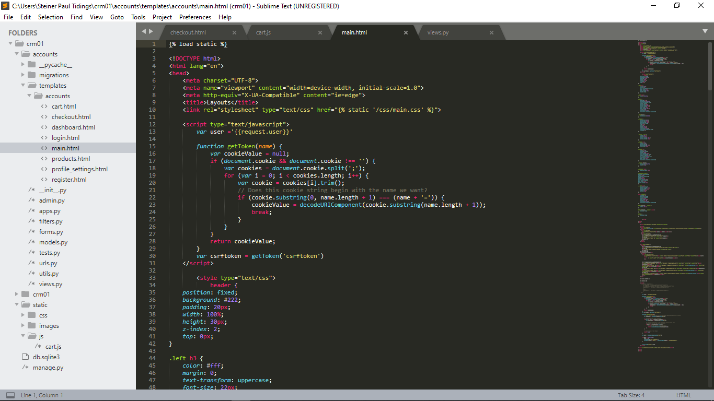

Figure 4.1

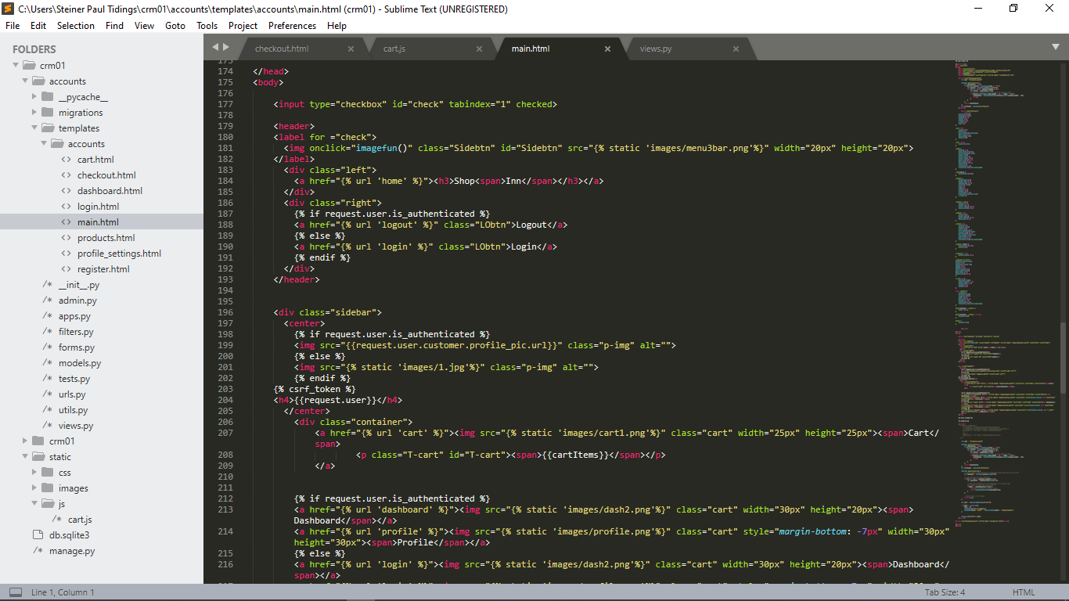

Figure 4.2

**Source:** Authors, 2021

These set of HTML codes were used to design the bar above at the top of the all the pages of the which is seen below

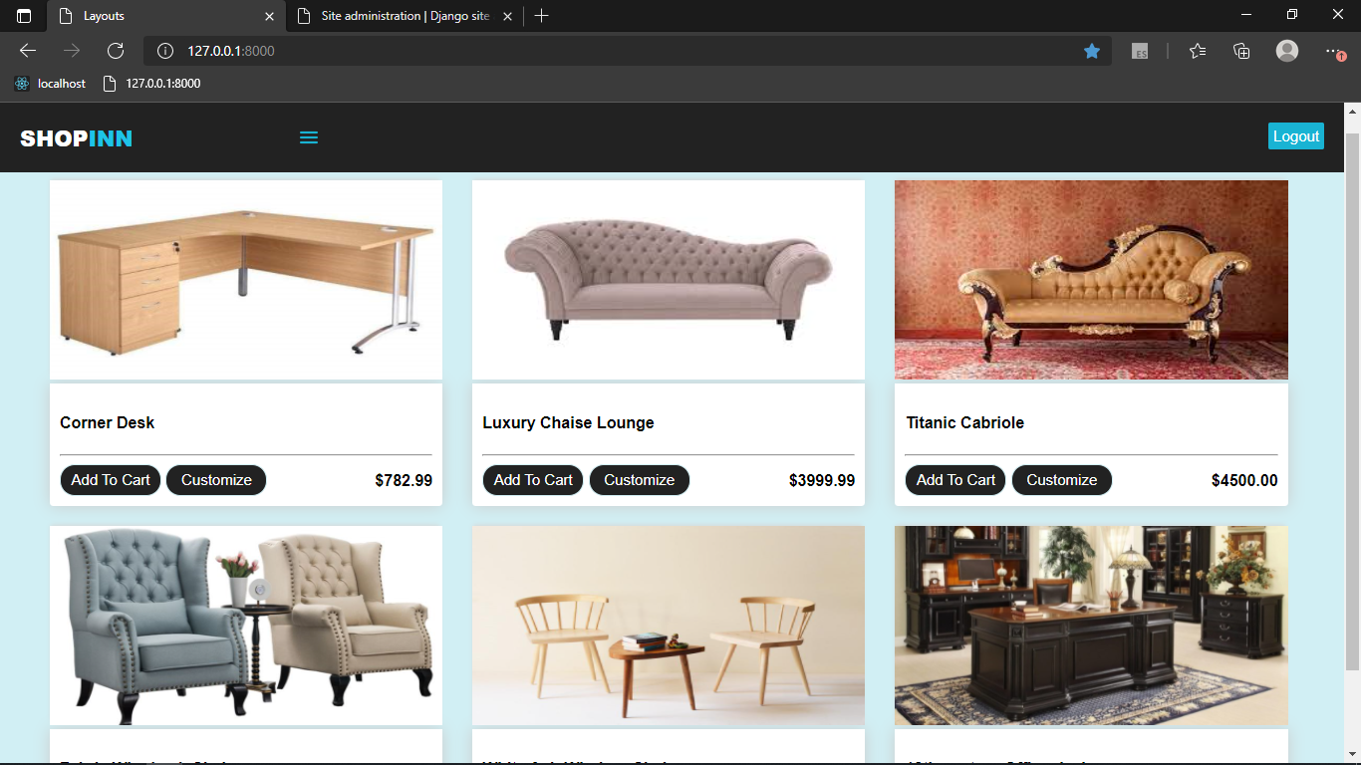

Figure 4.3

With the help of Python, we were able to apply these same codes to the other webpages without having to necessarily type them all out. With the Use of JavaScript also, the side navigation which we see below was also possible.

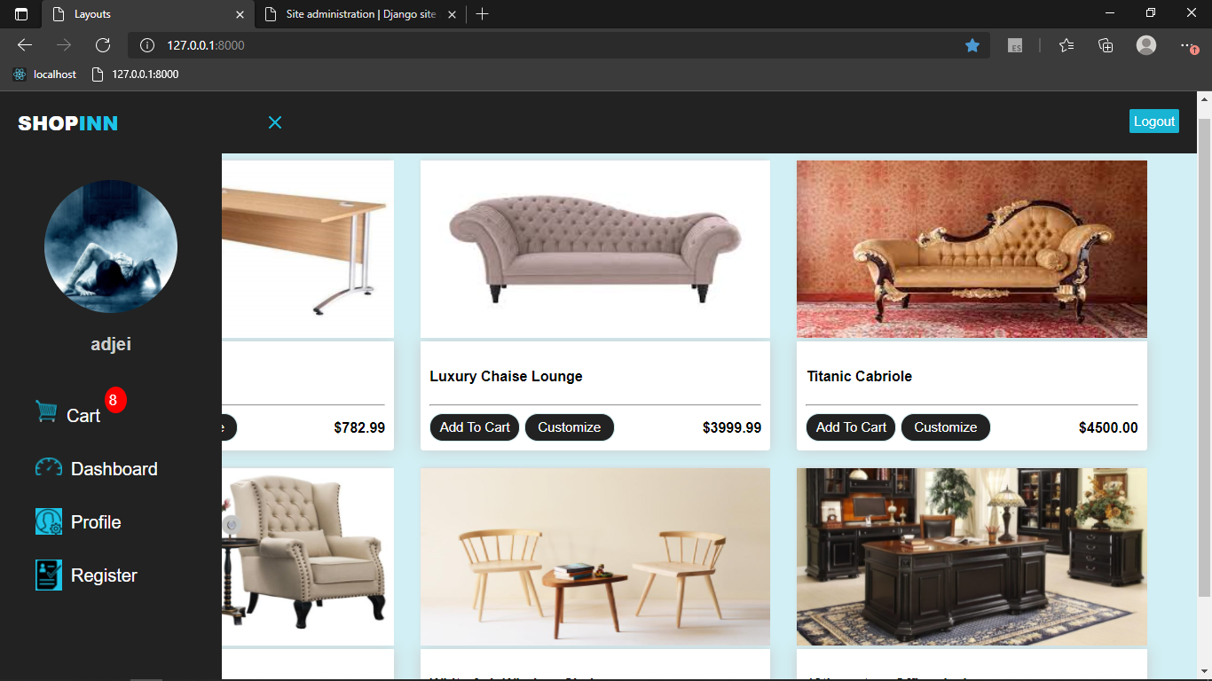

Figure 4.4

**Source:** Authors, 2021

The side navigation shows the name of the user, the users, profile picture, and 4 buttons leading to 4 different pages. Namely, the Cart button, Dashboard button. Profile settings button and the registration button.

### Products in the shop

The administrator is the only one with the ability to add products to the web application for the Users to select which they will like to buy. As the administrator, when inserting a product into the database, you will have to include the product name, the price, an image of the product and specify if the product is a digital product or not. Digital products are products that can be sent through digital means such as emails. Whiles products that aren’t digital are sent by physical means, meaning delivery which could be shipping or mailing. The product details are inserted into the HTML pages through python. The pictures below show the home page with the products and the codes for that page.



Figure 4.5

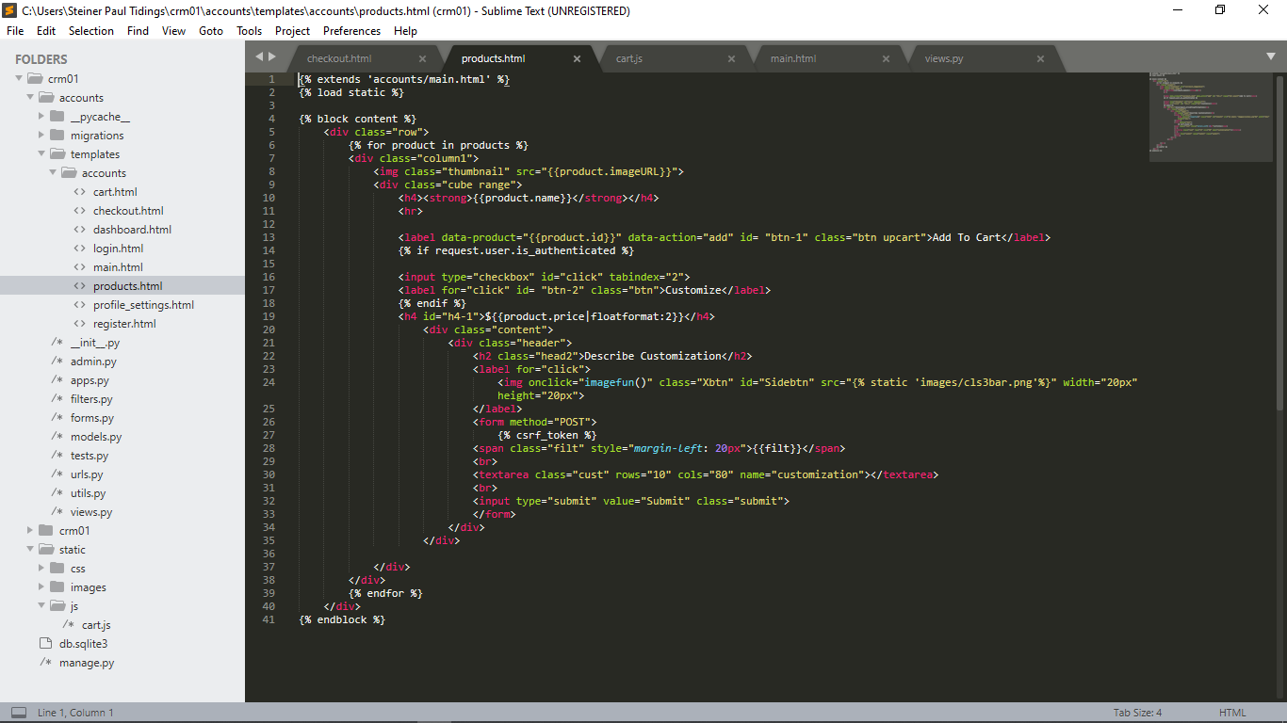

Figure 4.6

**Source:** Authors, 2021

### User Registration

The User will fill out the registration form with his personal information, excluding an image. A connection will then be created with the database after the form is submitted, and the data is saved. However, before the is saved, the data will be checked to see if it is valid, thereby making sure it is provided at where it is required.

The images below display the code that is used to process a user's registration as well as the registration page user interface.

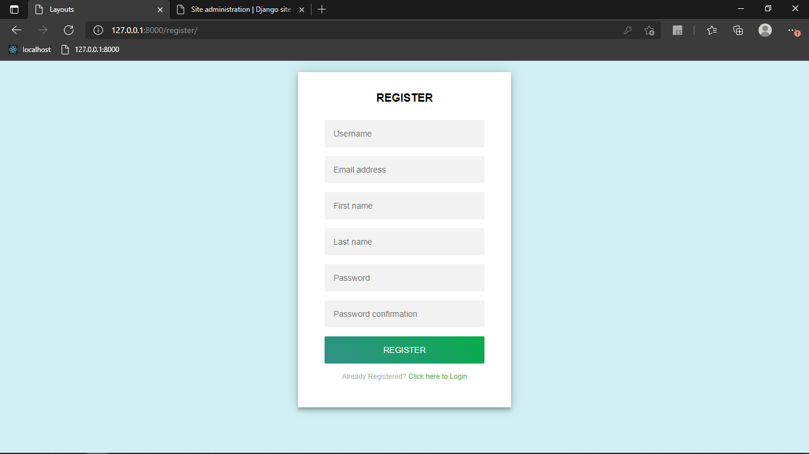

Figure 4.7

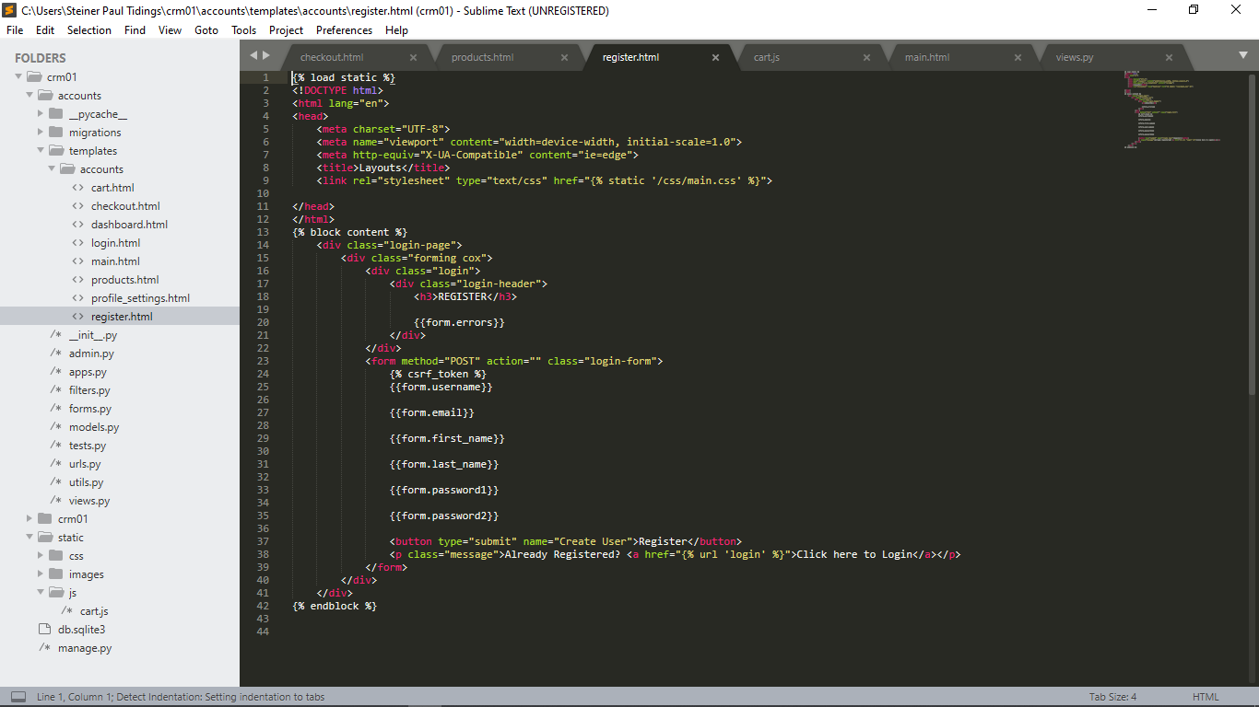

Figure 4.8

**Source:** Authors, 2021

### User Login

Like the User registration, The User will fill out the registration form with his personal information, excluding an image and a connection will then be created with the database after the form is submitted. However, the data here will be checked to see if it is valid as an already existing data. If it is invalid, the user will be told that his details are in valid. The Login page provides a link to the registration page where the user can register, in case the user would want to register instead of logging in.

The images below display the code that is used to process a user's login as well as the login page user interface.

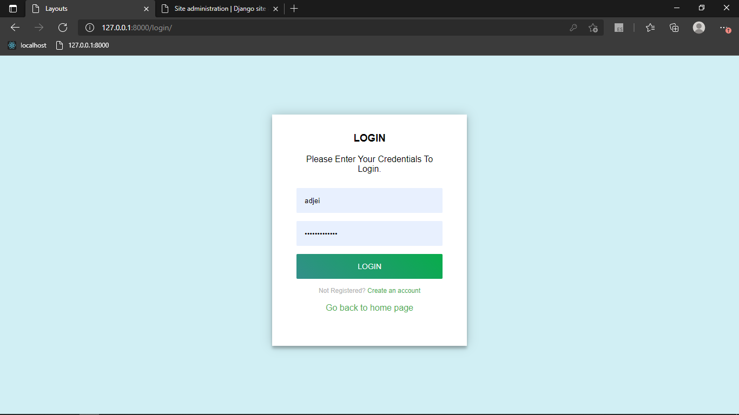

Figure 4.9

**Source:** Authors, 2021

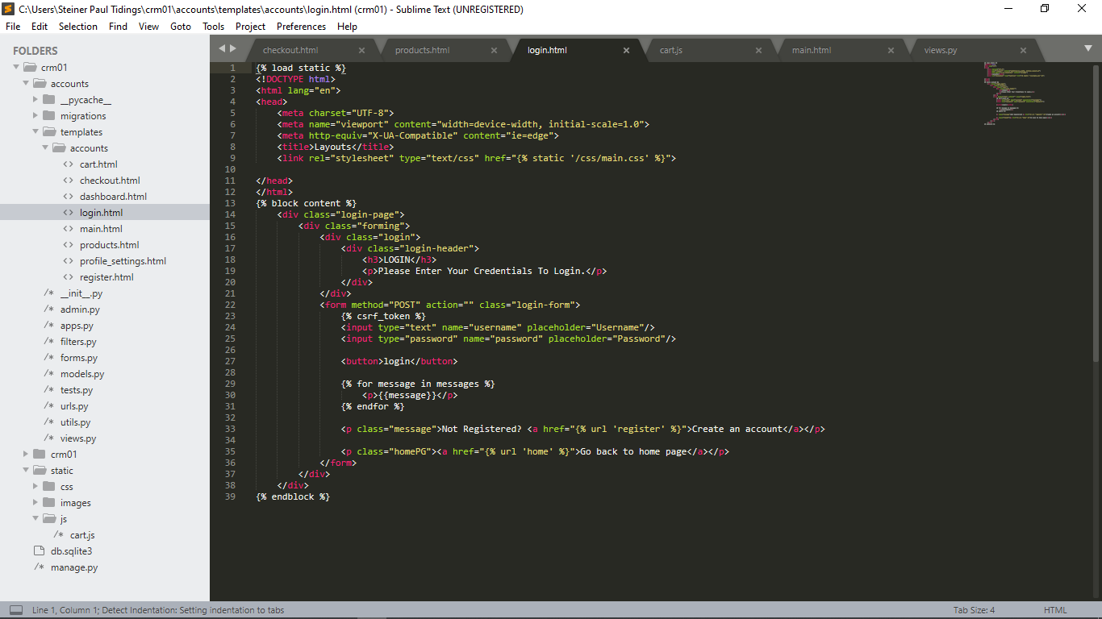

Figure 4.10

**Source:** Authors, 2021

### User Cart

All products that have been added a cart by a user are shown in that page. The page shows the images of the products added to the page, the names of each product, the price of each and also the total price of all the products in the current cart. The user can go ahead to increasing the quantity of a specific product he ordered by clicking the up-arrow button assigned to the product and can also reduce its quantity by clicking the down arrow-button. If the product is quantity is one and the user decides to press the down-arrow button, the product will automatically get deleted from the cart.

The images below display the code that is used to process a user's Cart as well as its user interface.

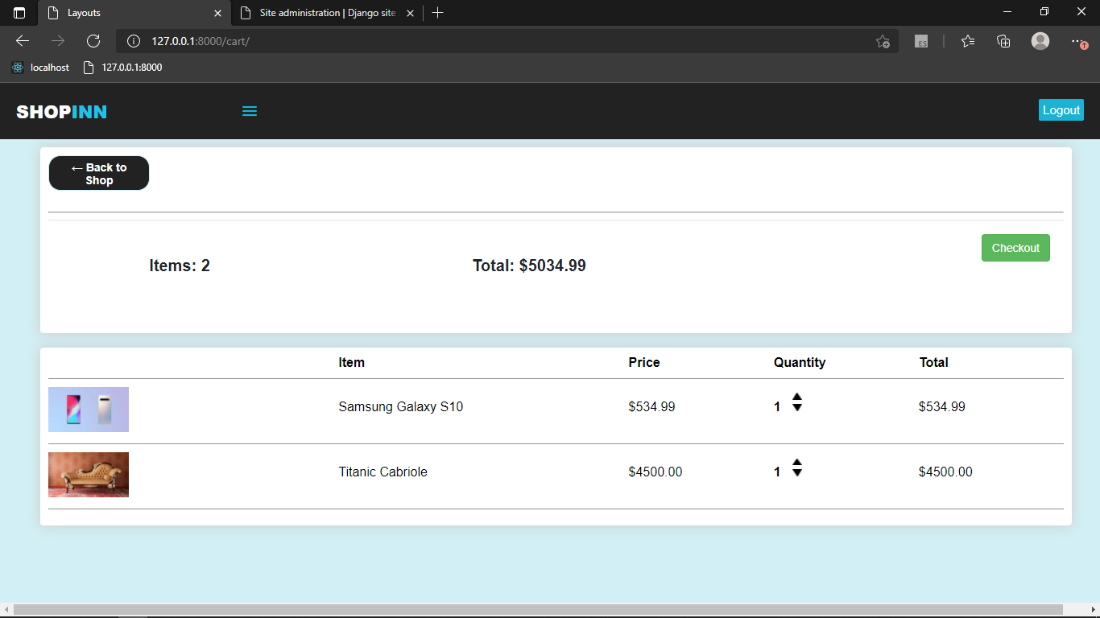

Figure 4.11

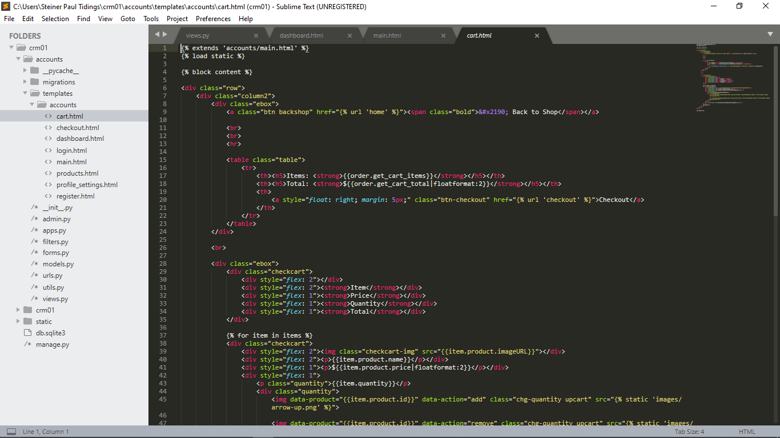

Figure 4.12

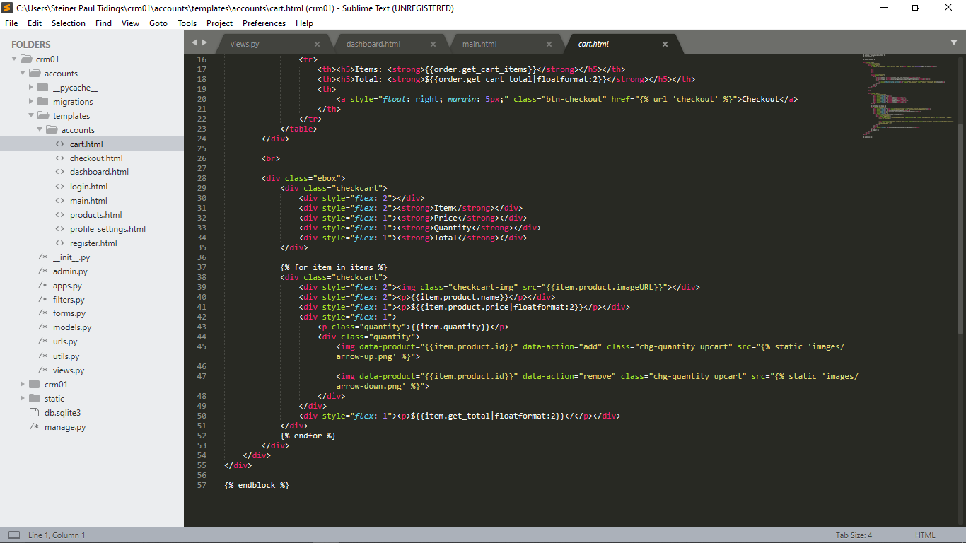

Figure 4.13

**Source:** Dennis Ivy, April 2020

### User Dashboard and proposed customization

For all products, the user is granted permission to propose a design to help the producer make his products better and satisfying. The proposals are done on the Home page by clicking the customize button under the tags of any product, typing the customization you have in the textbox provided and selecting the product to which the product is assigned to. The customizations to all products are stored in the database and shown to the user on the Dashboard page.

The dashboard page shows the total number of customers, total number of products ordered, total number of products sold on the web application and the total number of customizations the users have made. The dashboard also provides the list of products and their customizations. If the user wishes to search for a particular products customization, he can use the search button.

The images below display the code that is used to process a user's dashboard and customization feature as well as its user interface.

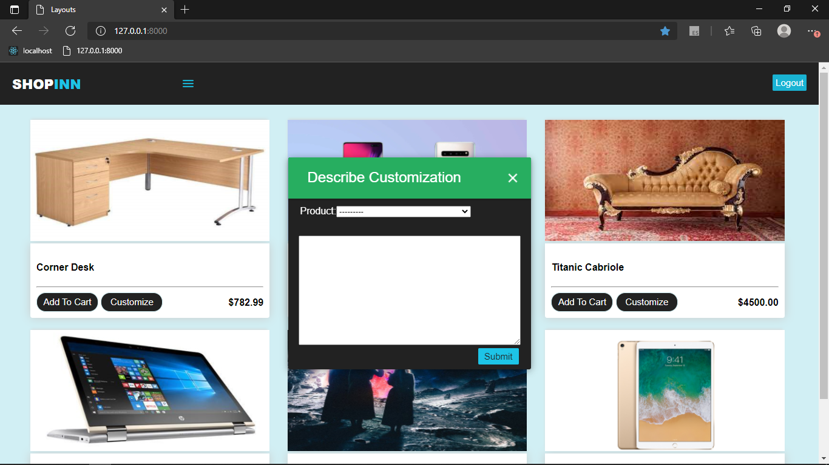

Figure 4.14

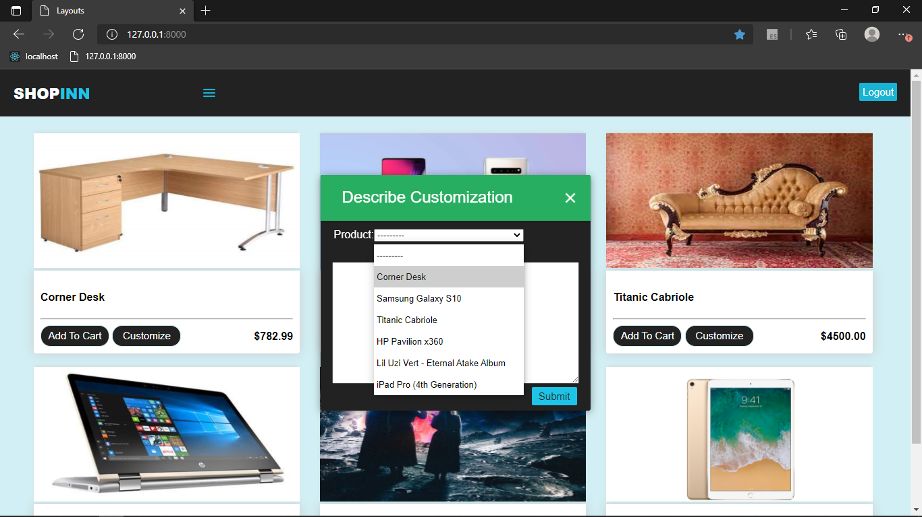

Figure 4.15

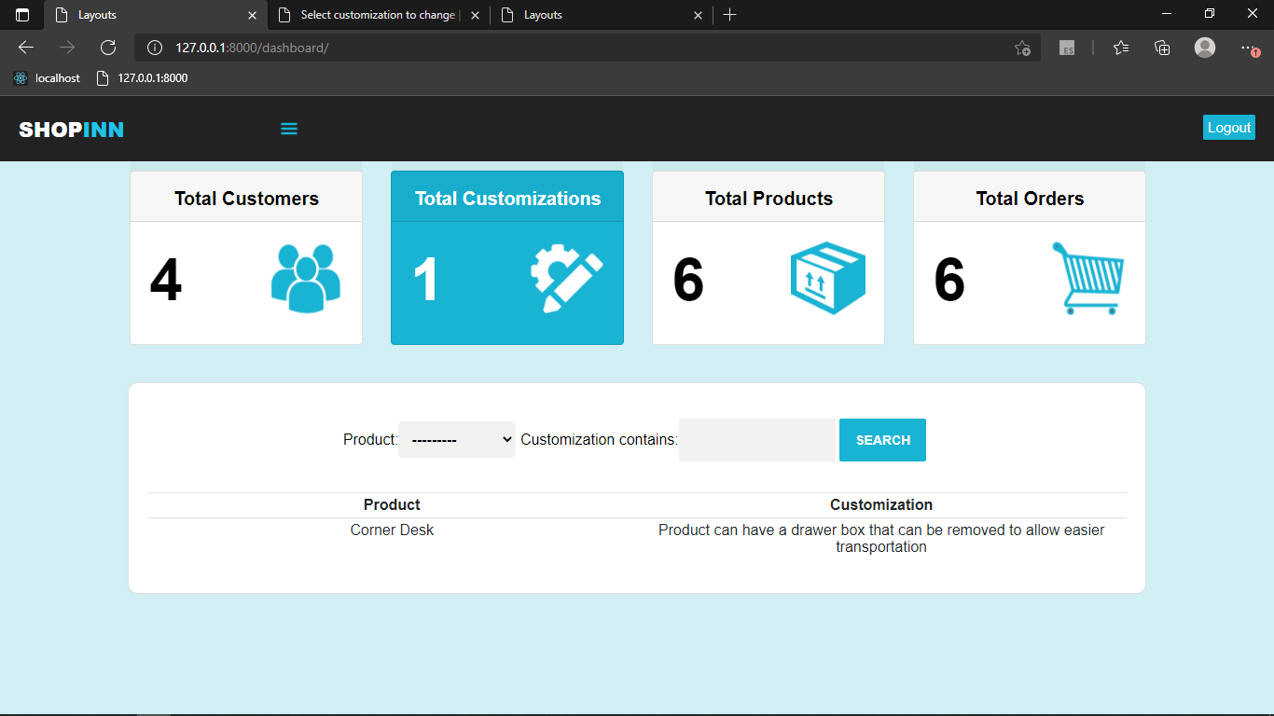

Figure 4.16

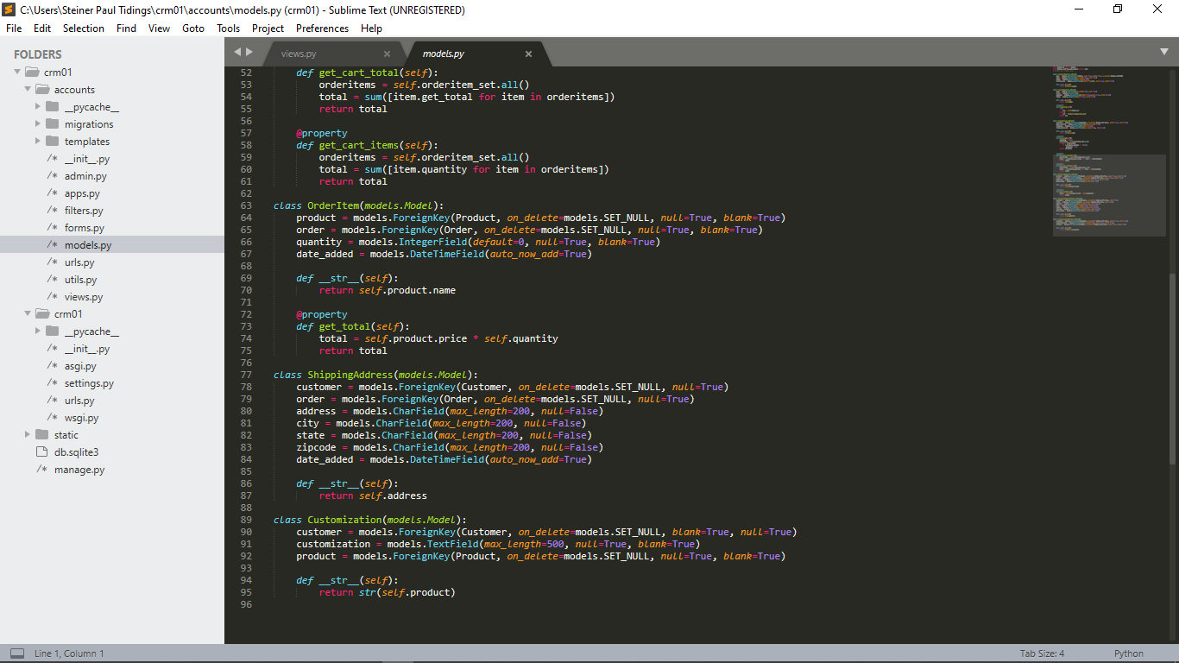

Figure 4.17

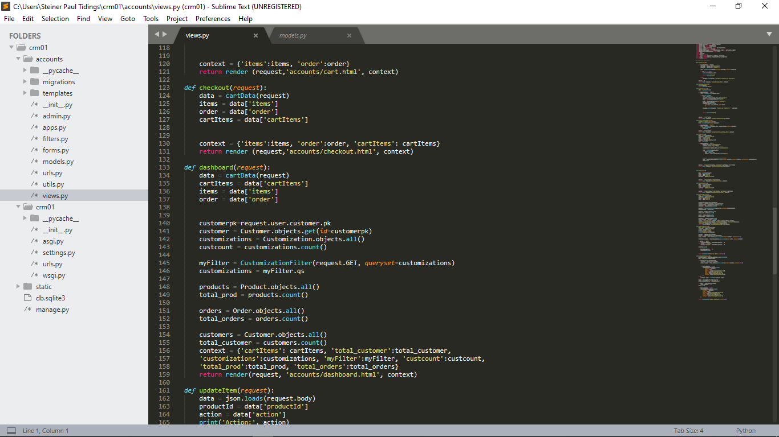

Figure 4.18

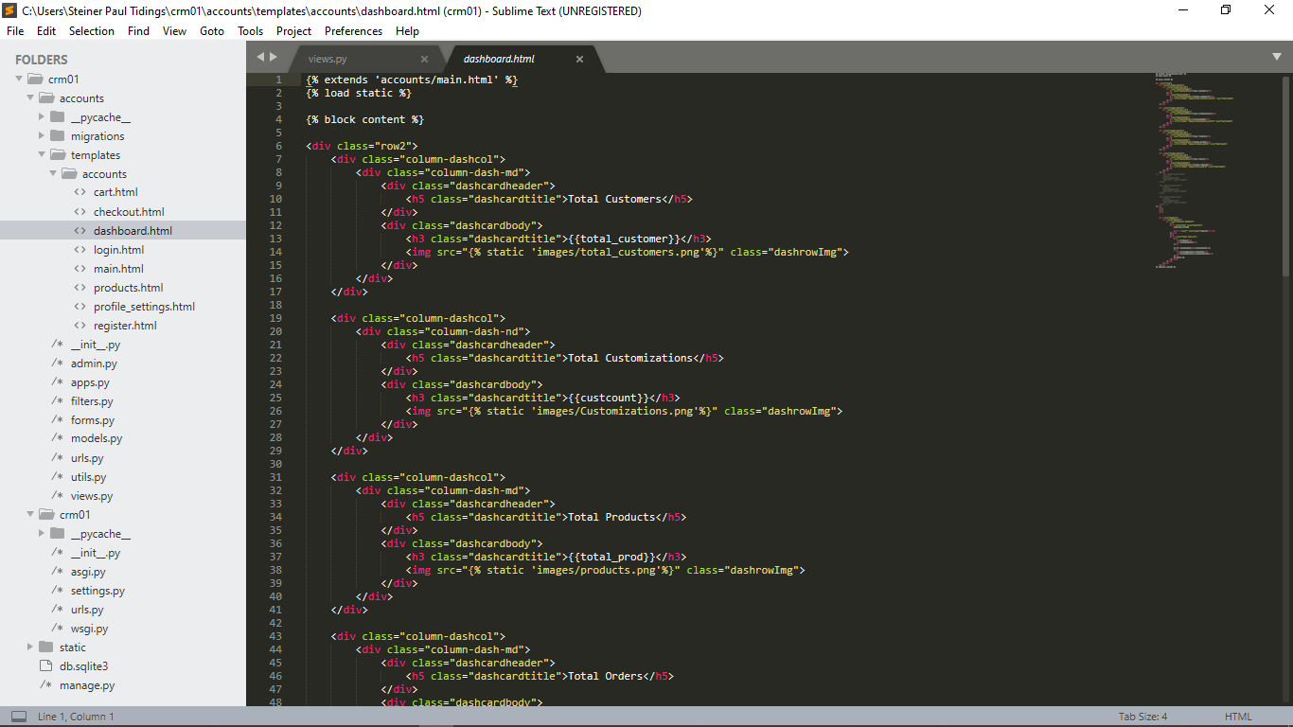

Figure 4.19

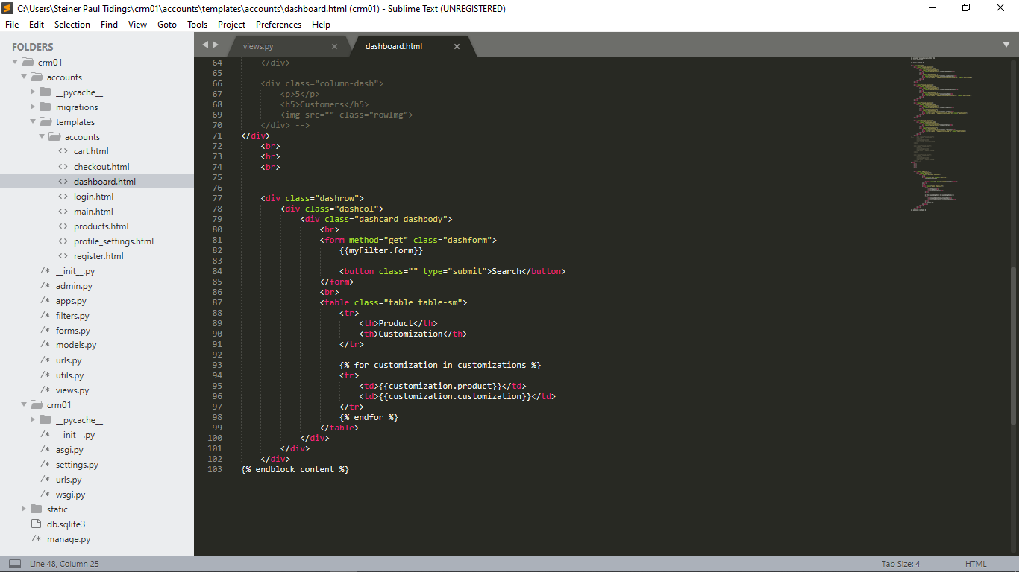

Figure 4.20

**Source:** Authors, 2021

### The User’s Checkout page

The user needs to checkout when he or she is done making an order. The user checks out by providing information which help in making the delivery and also provide details for how the payment will be made and finally make the payments. For the payments, to methods are allowed by the Web Application. That is, payment through PayPal and payment through a Credit or Debit Card. Payment option wouldn’t be activated until the shipping information is entered.

Images to support this have been provided below.

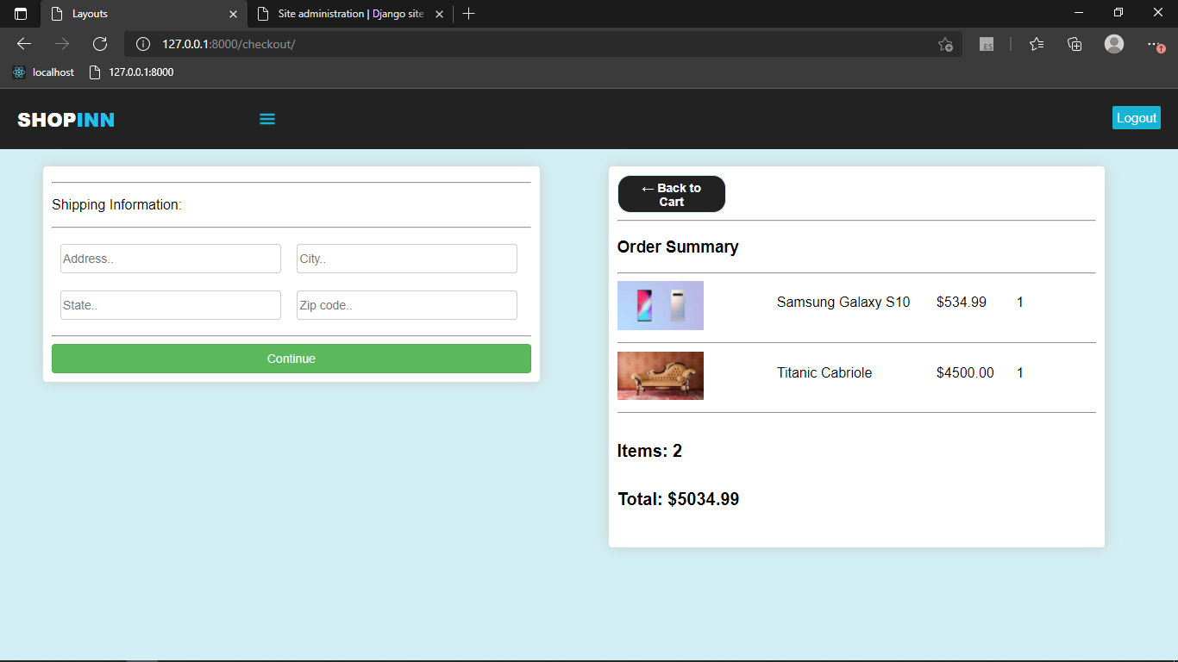

Figure 4.21

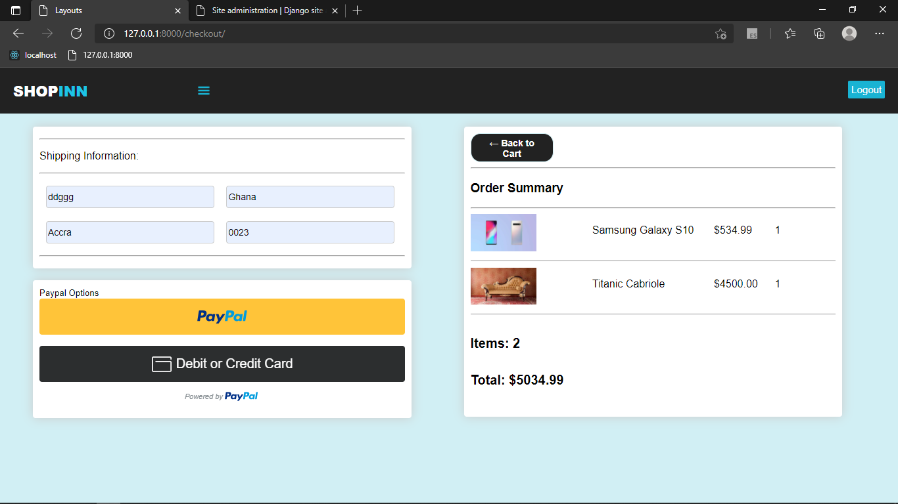

Figure 4.22

**Source:** Dennis Ivy, April 2020

### The Administrator’s page

Django creates a page for the administrator automatically when a project is started in Django Python. Since the user interface is already built out with the HTML, CSS, JavaScript and python, the only codes you’ll have to type out is how the data will be handled on that page. This code would include what data the page should fetch for the database, the user authentication process and many others. When a project is created in Django, Django automatically creates a database in MySQL and waits for the administrator to give instructions on the kind of tables it should create in the database file.

The basic page for the Administration is displayed below

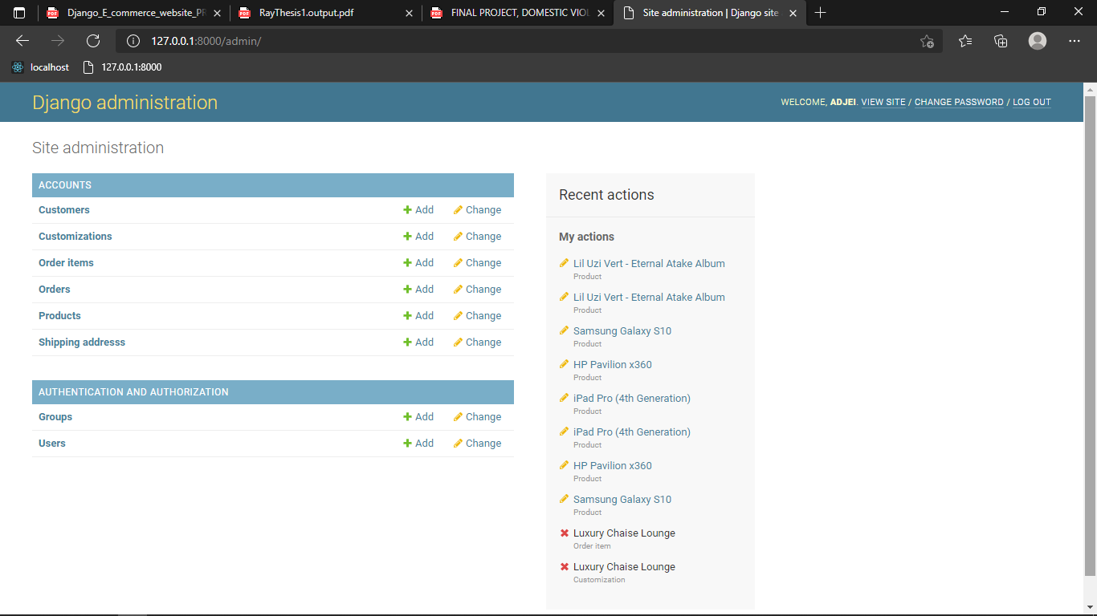

Figure 4.23

**Source:** Authors, 2021

# Chapter Five: CONCLUSION AND RECOMMENDATION

## Introduction

This chapter closes this documentation with a conclusion on the project's design and construction by discussing on whether or not the project's goal was met, the limits encountered while working on the project, and recommendations.

## Conclusion

HTML5, CSS3, JavaScript, Python and Django were used to create the electronic commerce web application. With the application, any customer can browse products, add or remove items from their shopping cart. With the user details, such as his email and password, the user can make purchases as an authenticated user. If the user decides to login but provides invalid details, the user can either re-register or request a password change. After logging in, the consumer can view the product in their cart and continue shopping. PayPal can be used to pay for the item. The order can be verified by the administrator, but the customer can still view the orders in his or her account. The database saves the ordered price.

## Lessons Learnt

These are just a few of the invaluable lessons learned during this project:

Tolerance: With this we learnt how to be tolerant of criticism, to take critical feedback for improvement, to handle stress, and to remain sober in all of these situations.

Perseverance: As an attitude of persistence despite difficulties or delay in obtaining accomplishment and always working hard to meet set targets or goals, we learnt perseverance

Teamwork: This project granted us a sense of passion for shared goals and tasks.

## Recommendations

In our project, there is a lot of room for improvement. In the future, a lot of features, such as giving, could be added to this system. The feature of including a search engine that makes it easy to find for different products from the store. Another feature we wanted to include was the ability to assign clients to classes so that different offers could be made to each class. If time and expertise had not been a constraint, these features could have been added.

# Reference

1. E.W.T. Ngai, F.K.T. Wat, May, 2001. A literature review and classification of electronic commerce research. Hong Kong: The Hong Kong Polytechnic University
2. Shahrzad Shahriari , Mohammadreza Shahriari , Saeid gheiji, April,2015. E-Commerce and It Impacts on Global Trend and Market. India: International Journal of Research – Granthaalayah
3. C.J. Anumba, K. Ruikar, November 2001. Electronic Commerce in Construction - Trends And Prospects. Loughborough: Loughborough University
4. Raymond Kumah, 2018. An E-Commerce Shopping Website. Vaasan Ammattikorkeakoulu University Of Applied Sciences
5. Abdullah Saleh Alqahtani and Robert Goodwin, 2012. E-commerce Smartphone Application. Australia: International Journal of Advanced Computer Science and Applications
6. Swati Gupta, June 2013. Online Shopping Cart Application. North Dakota: North Dakota State University Graduate School
7. Vatrapu, Sidhartha Reddy, 2014. Design and Implementation of E-Commerce Site for Online Shopping. Governors State University: All Capstone Projects
8. [www.w3school.com](http://www.w3school.com/)
9. <https://developer.paypal.com/developer/accounts>
10. [https://developer.paypal.com/demo/checkout/#/pattern/client](https://developer.paypal.com/demo/checkout/%23/pattern/client)
11. <https://developer.paypal.com/developer/applications>
12. Victor O. Owino, 2020, La BELLE Fashions Store. Kenya: University of Eldoret
13. [https://codewithsteps.herokuapp.com/project/cd0492f3-ee93-471a-9dbc-b047233336c3/#overview](https://codewithsteps.herokuapp.com/project/cd0492f3-ee93-471a-9dbc-b047233336c3/%23overview)

# Appendix

This section contains other source codes to the success of this project that have not been mention in the other sections of this documentation

## Hypertext Markup Language Codes

### Main.html

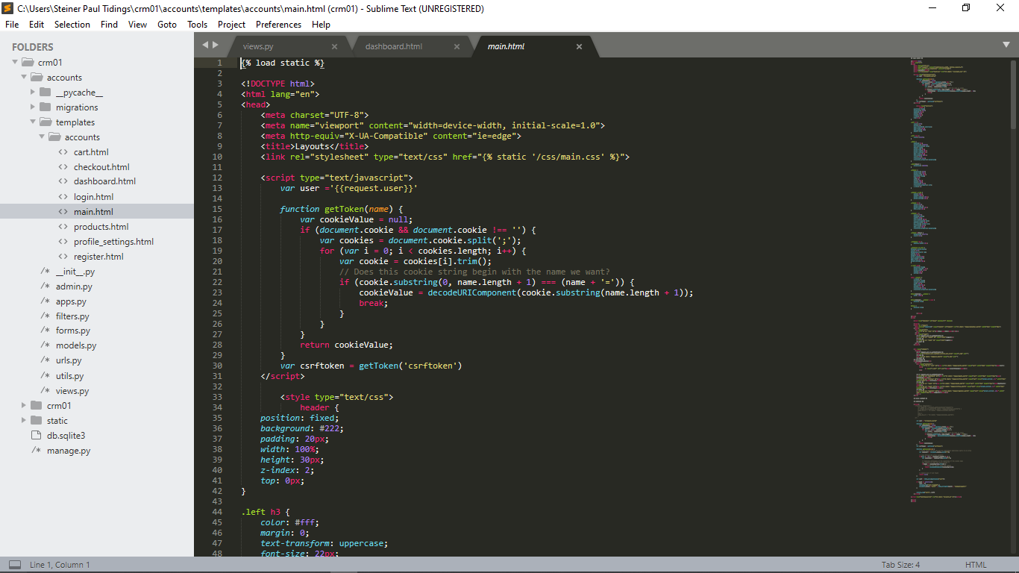

Figure 6.1

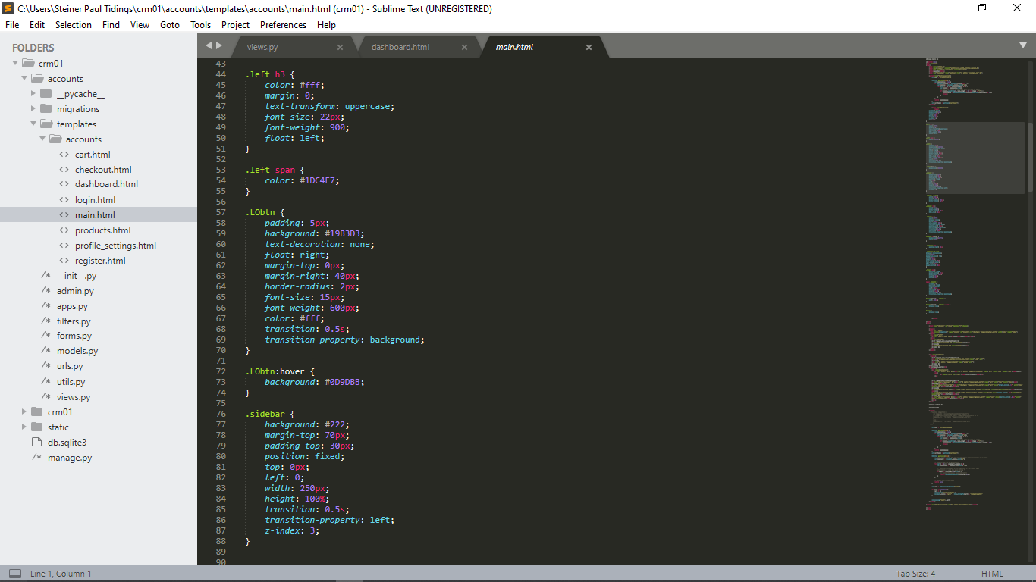

Figure 6.2

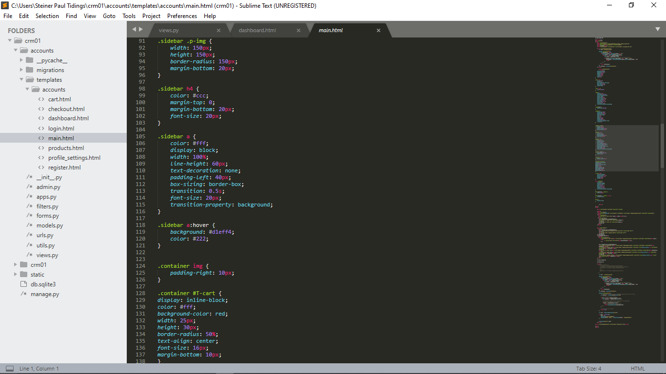

Figure 6.3

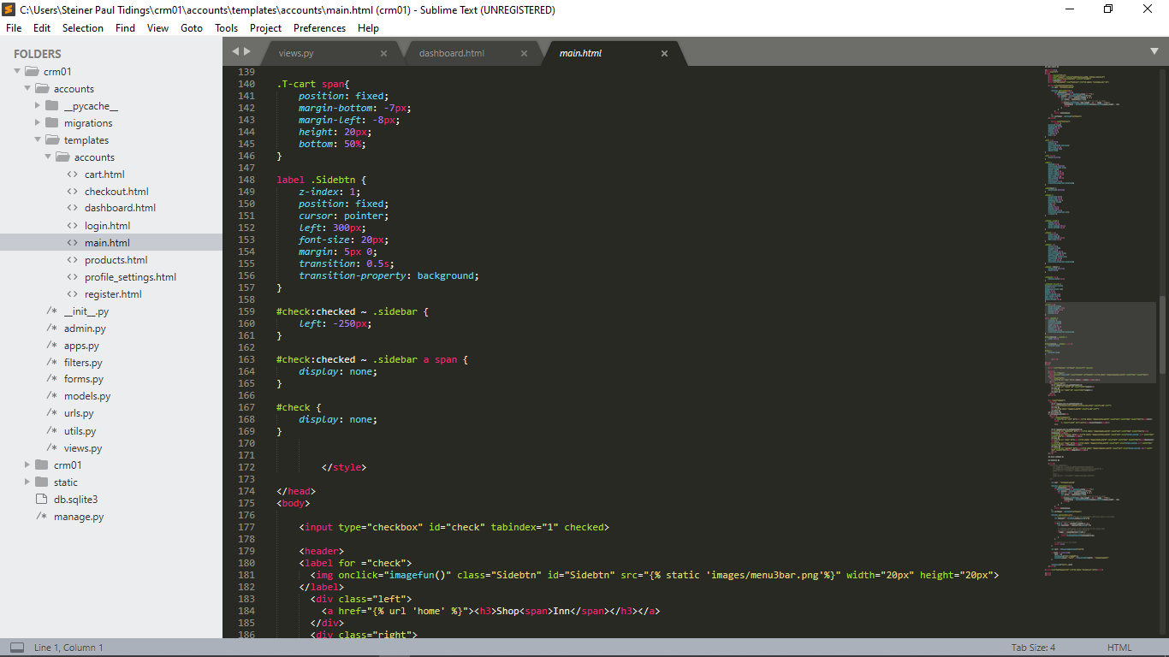

Figure 6.4

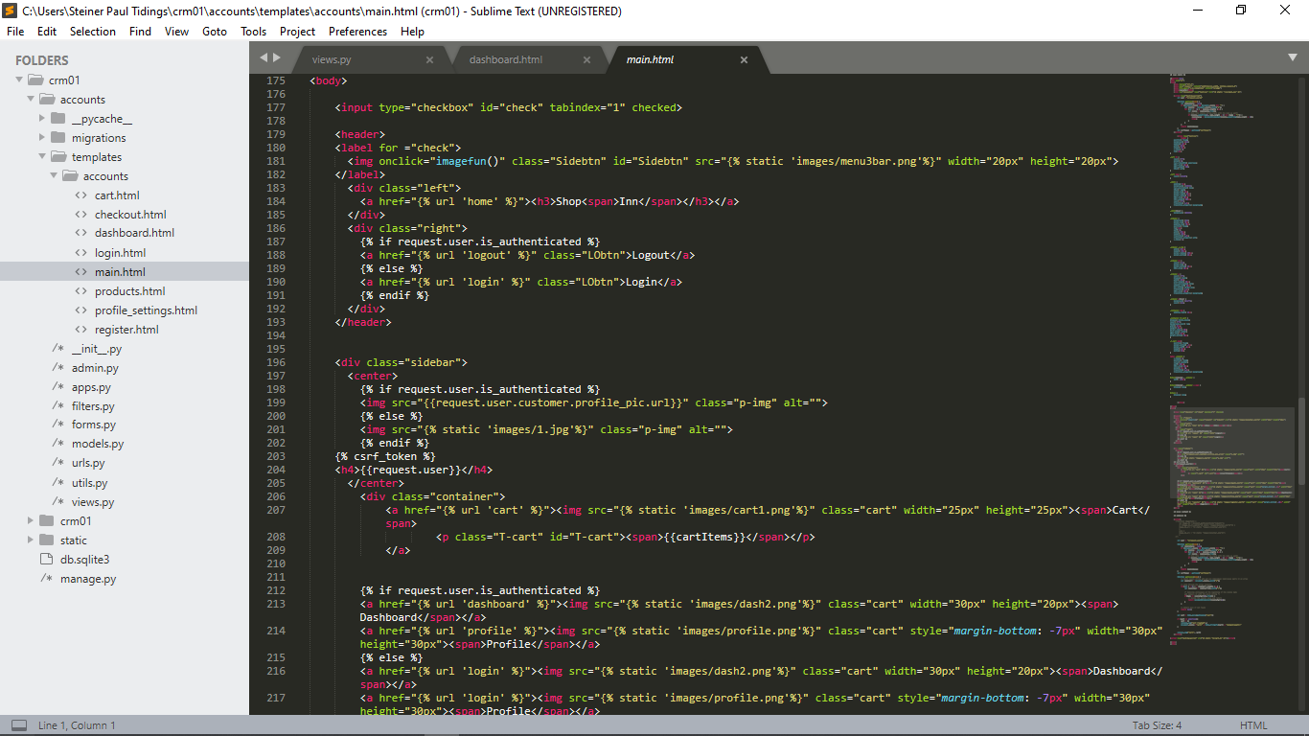

Figure 6.5

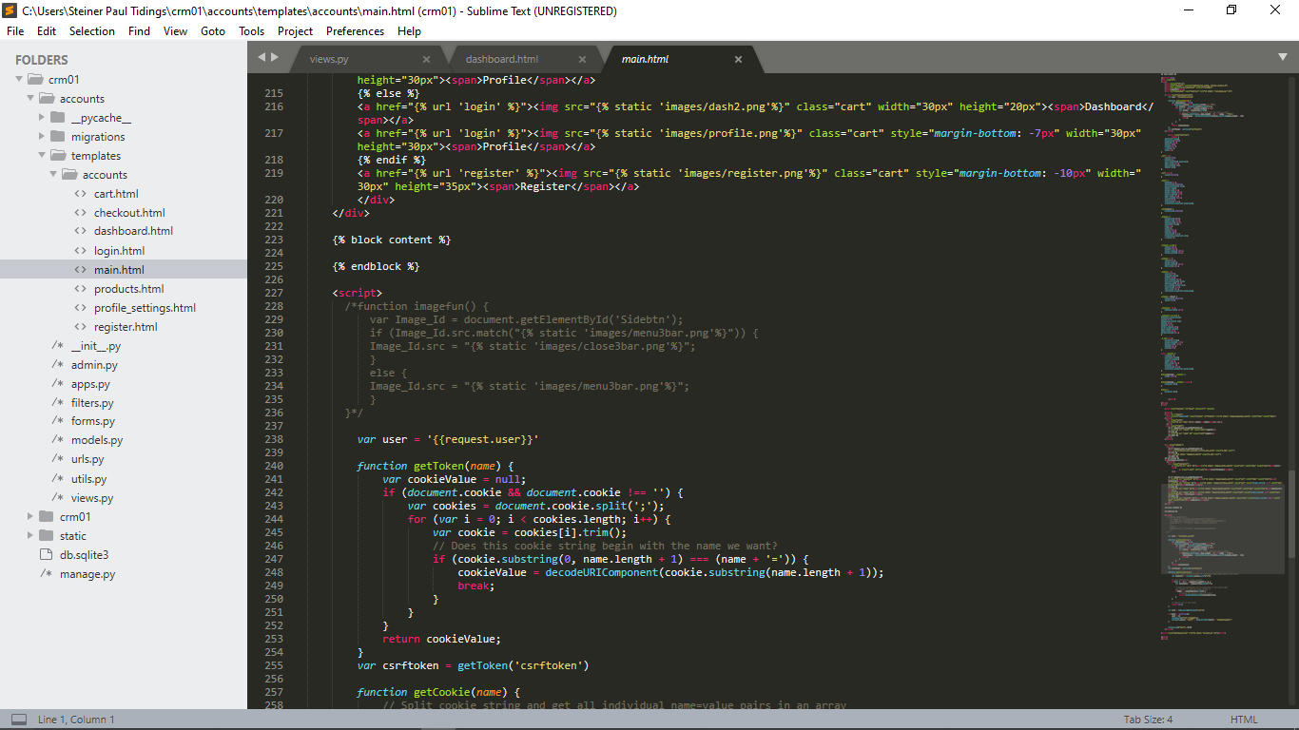

Figure 6.6

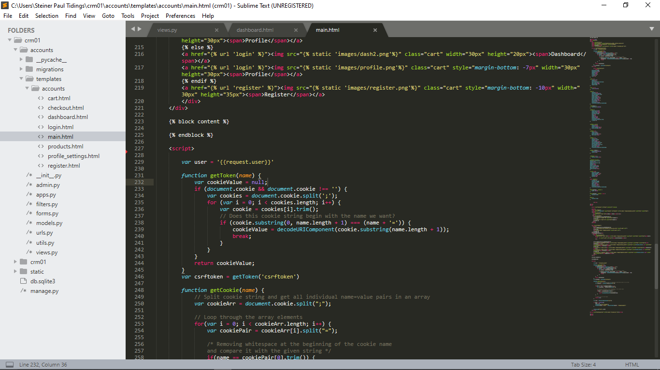

Figure 6.7

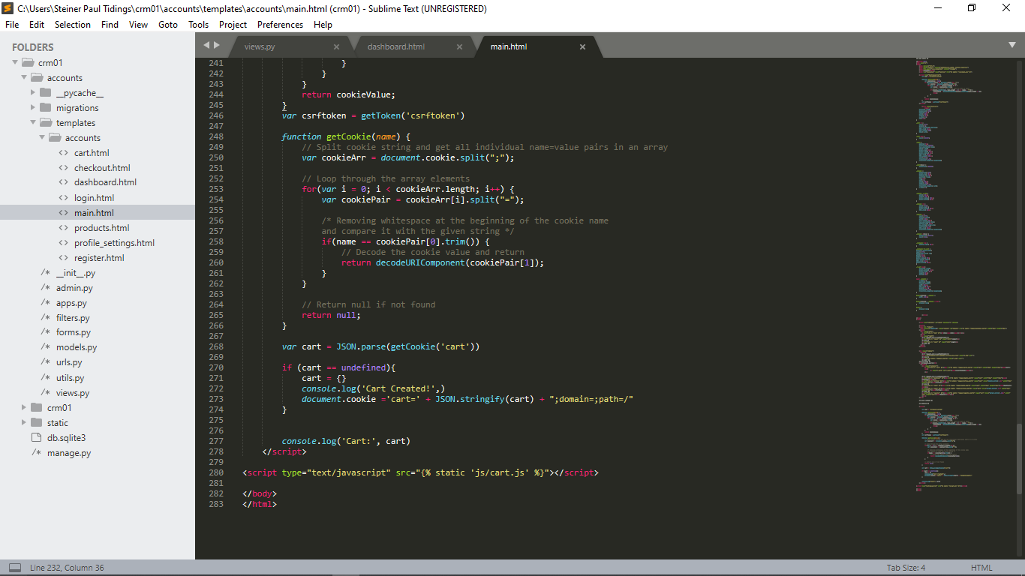

Figure 6.8

### Checkout.html

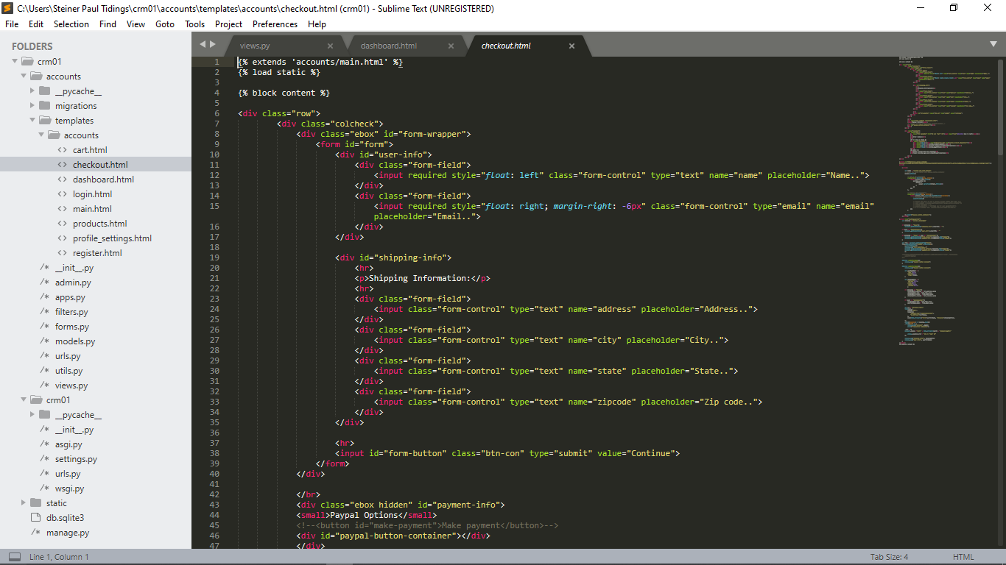

Figure 6.9

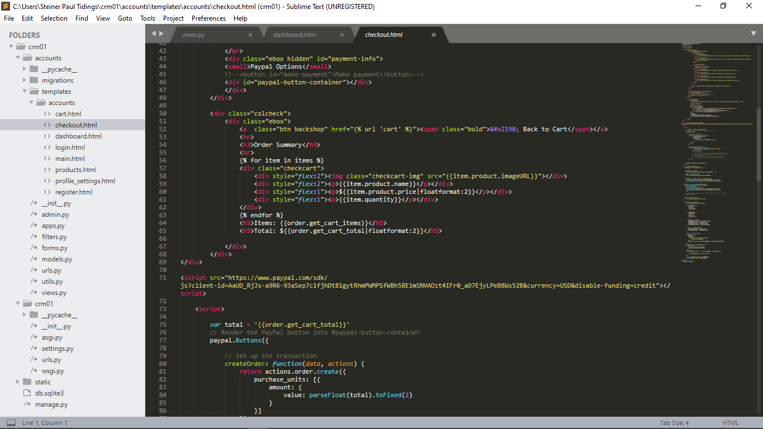

Figure 6.10

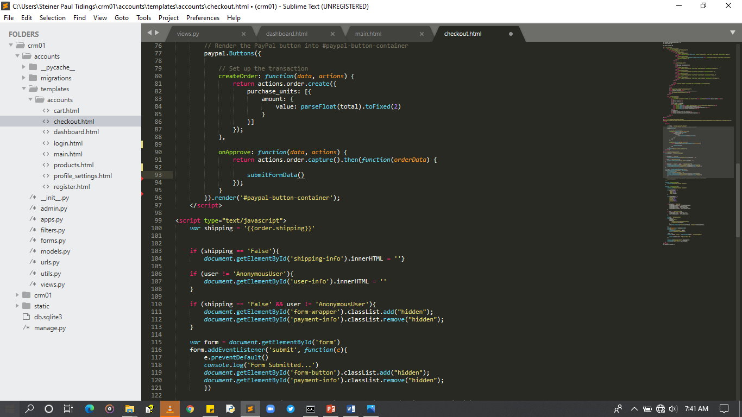

Figure 6.11

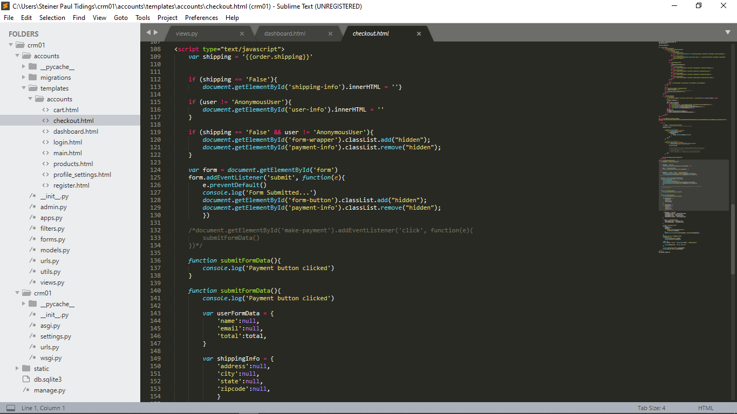

Figure 6.12

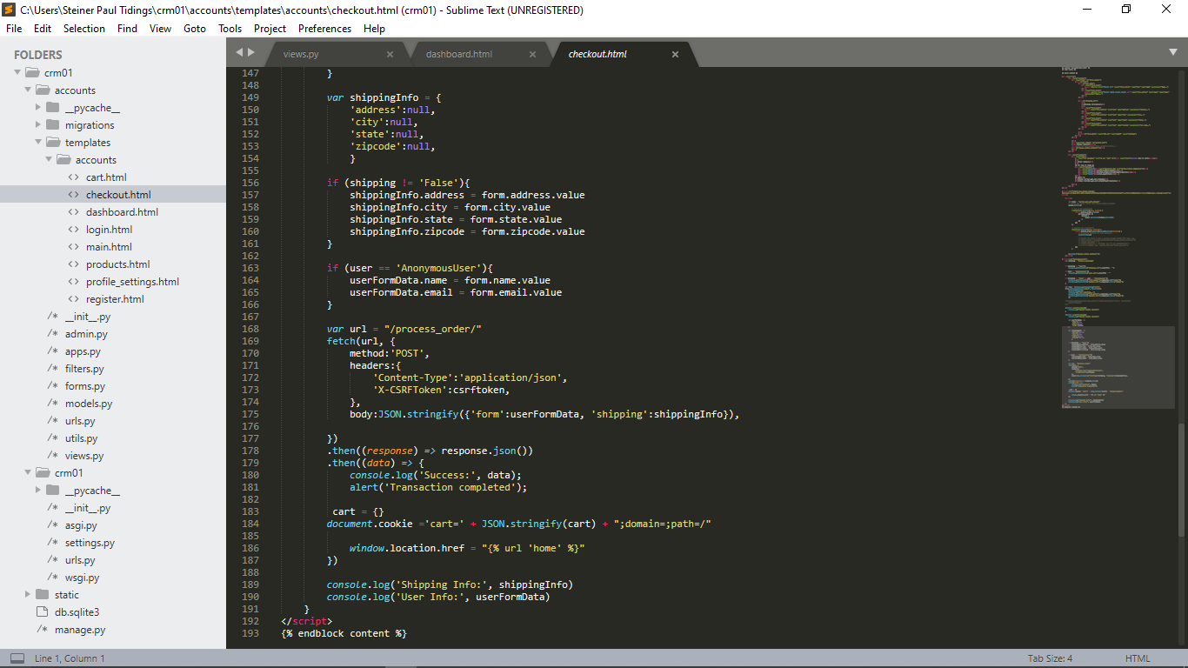

Figure 6.13

### Profile_settings.html

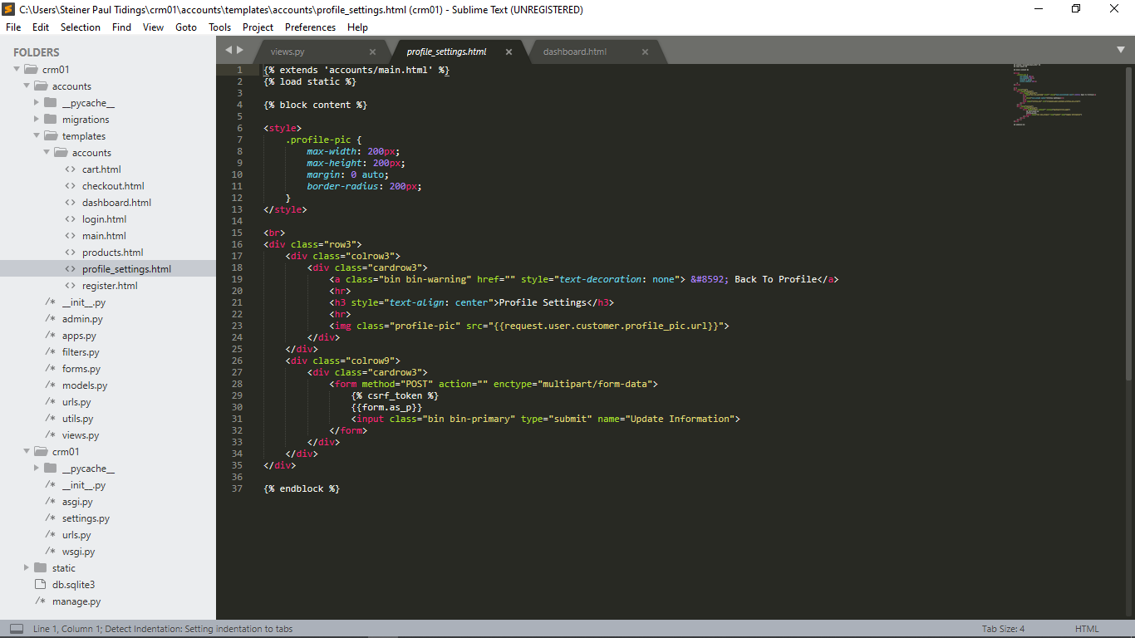

Figure 6.14

## Cascading Style Sheet Codes

### Main.css

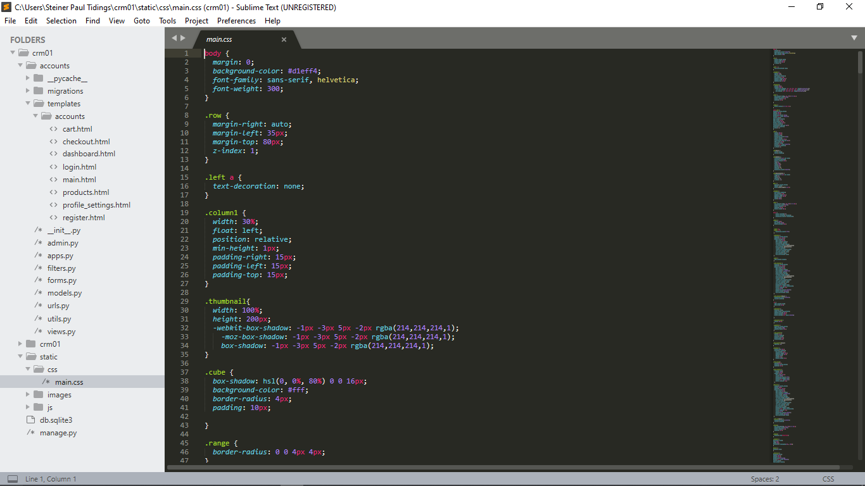

Figure 6.15

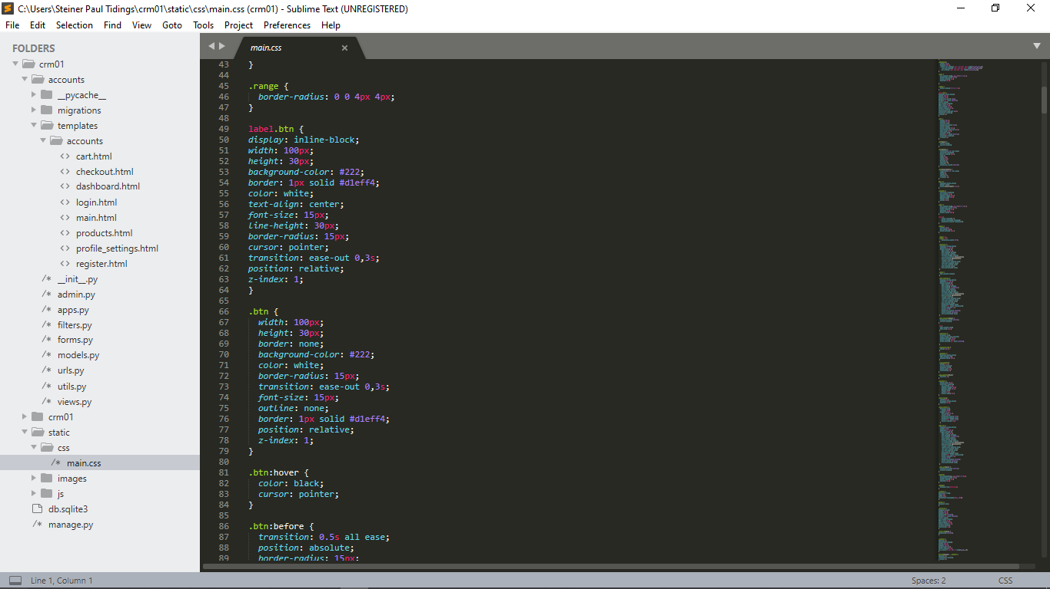

Figure 6.17

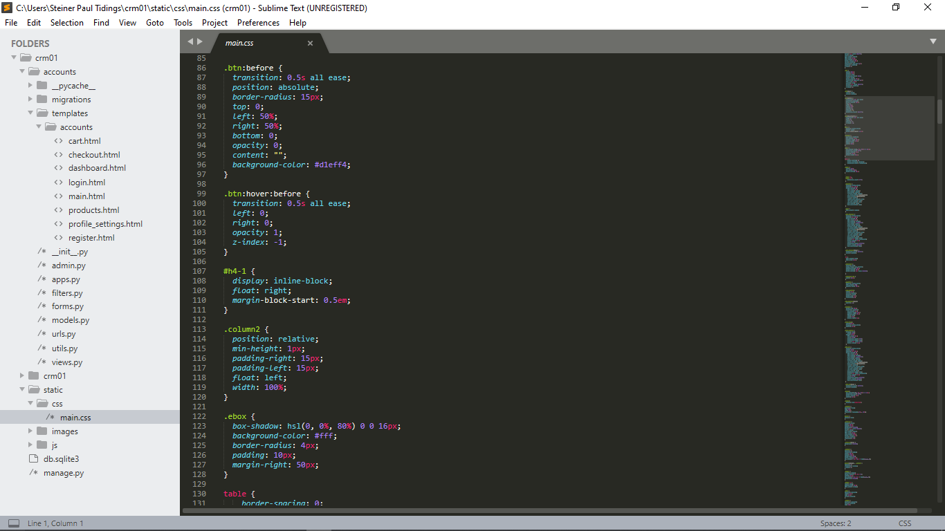

Figure 6.18

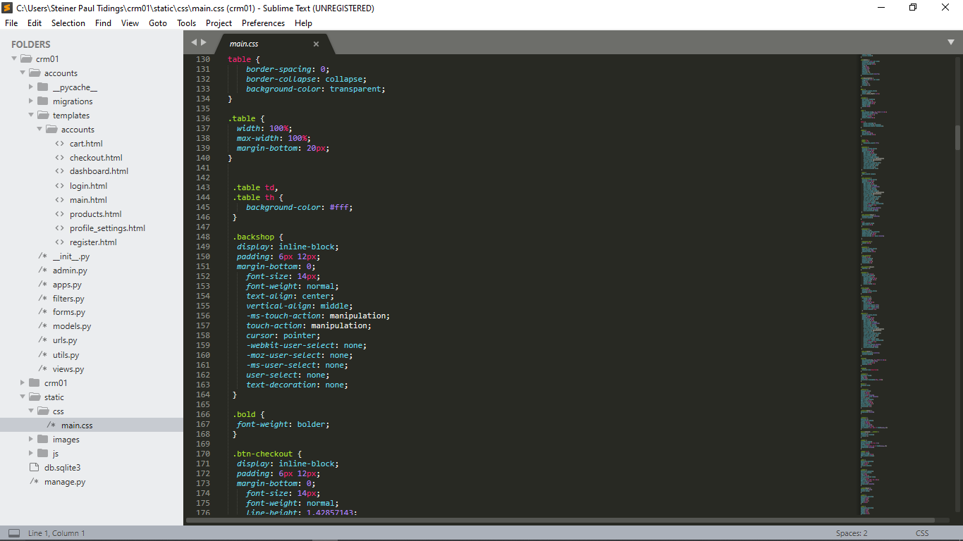

Figure 6.19

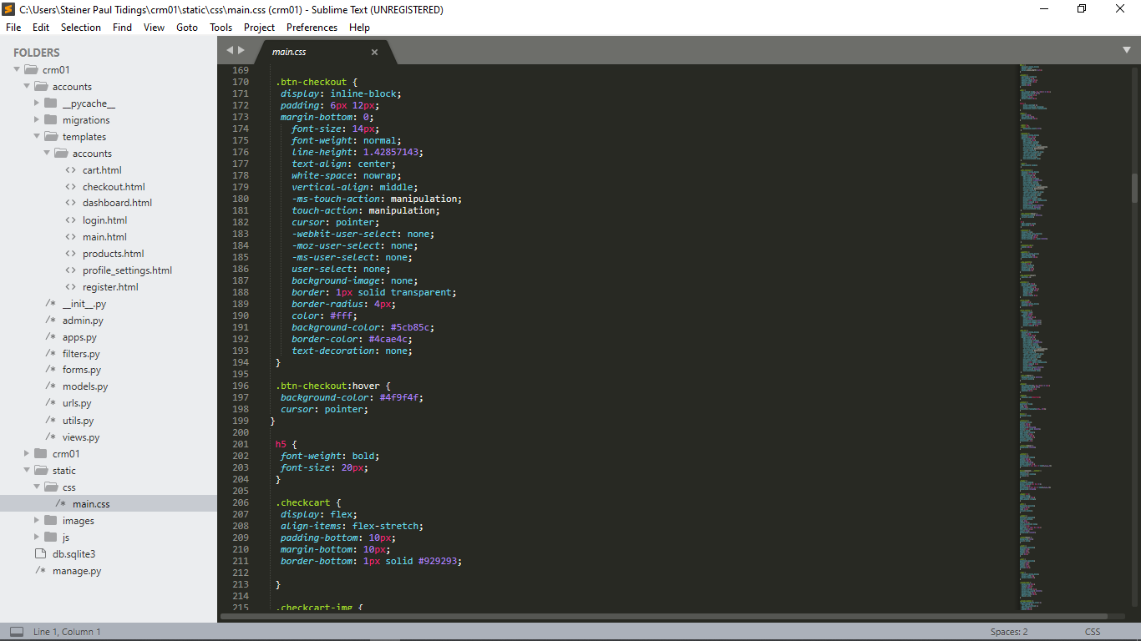

Figure 6.20

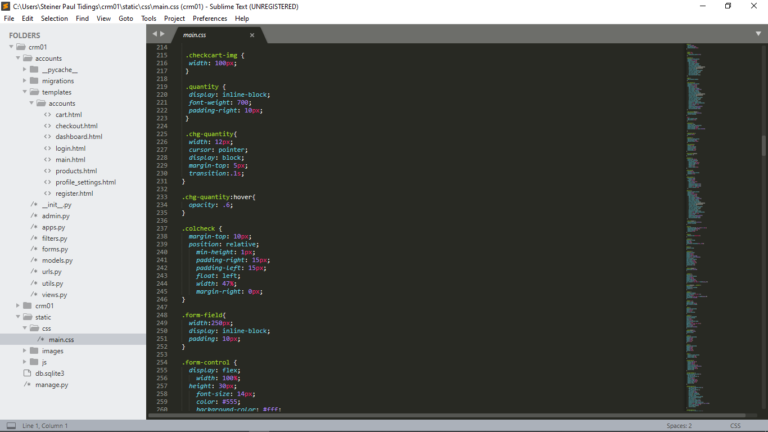

Figure 6.21

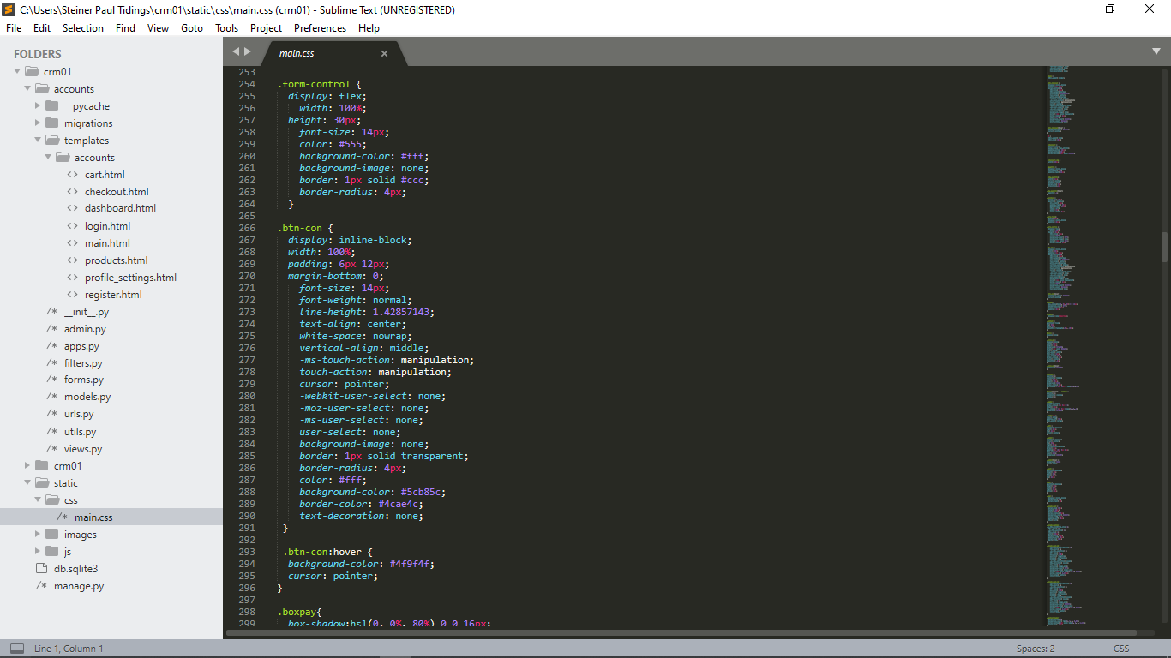

Figure 6.22

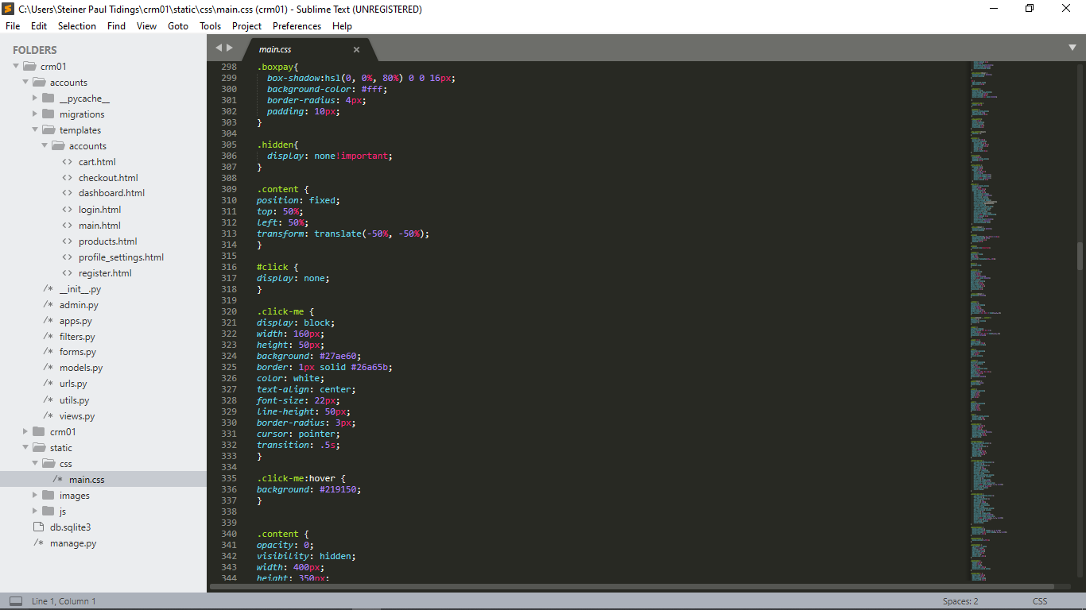

Figure 6.23

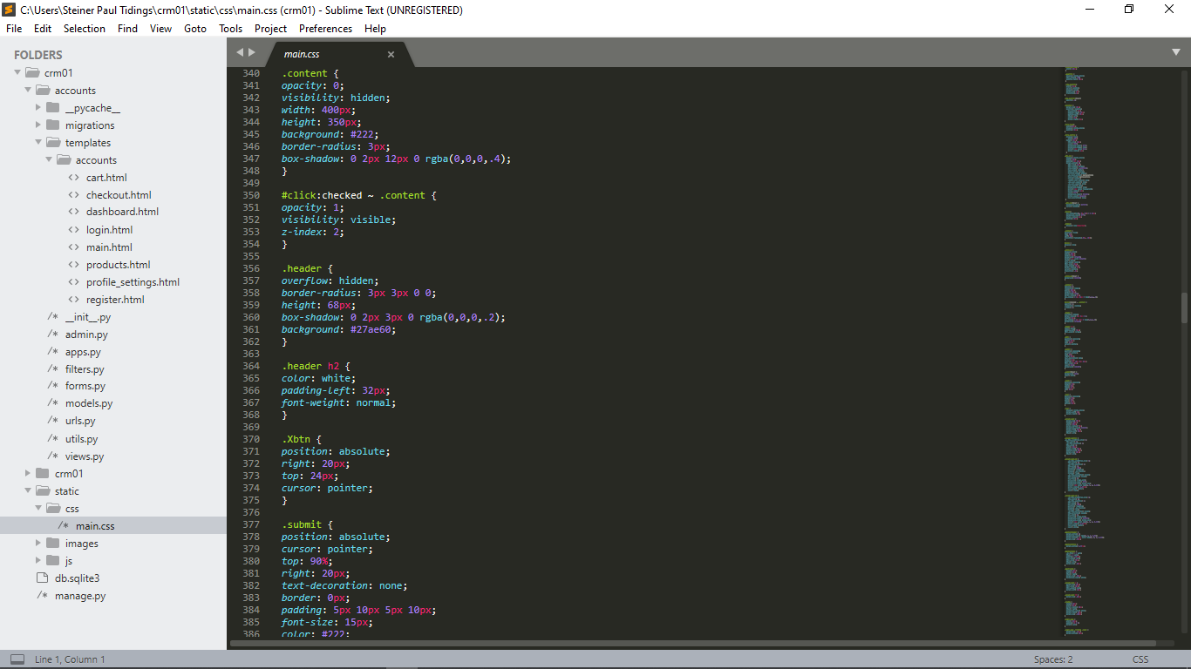

Figure 6.24

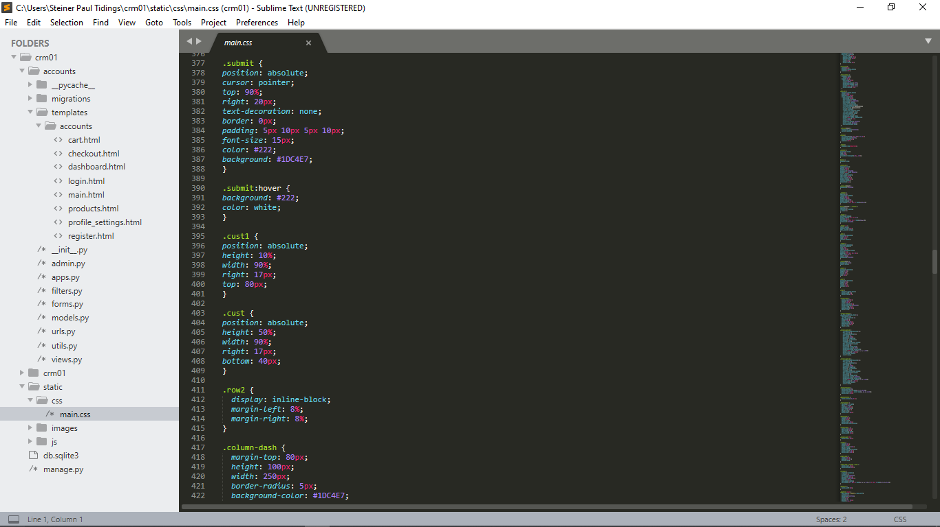

Figure 6.25

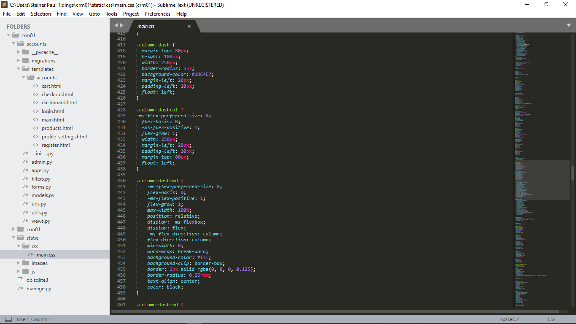

Figure 6.26

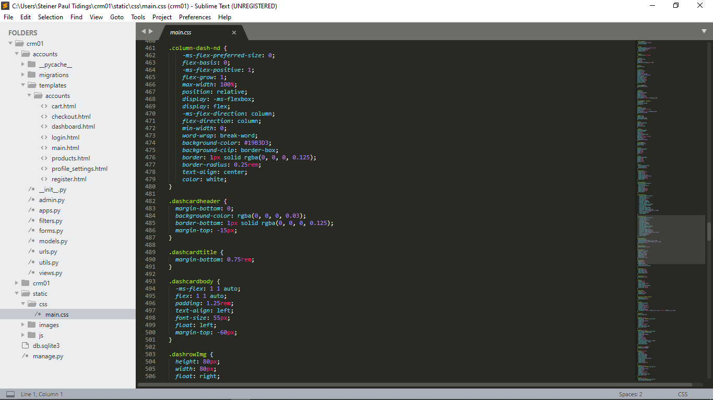

Figure 6.27

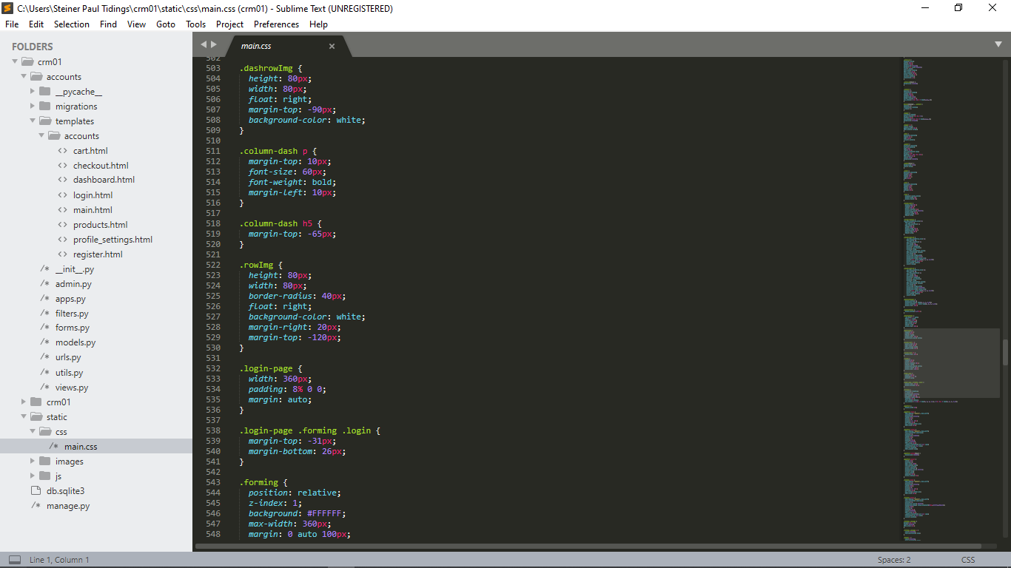

Figure 6.28

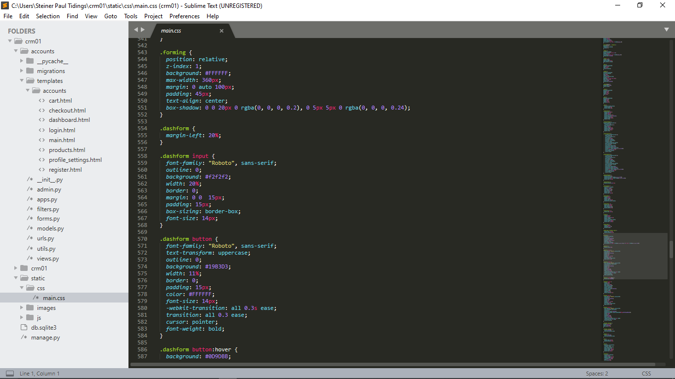

Figure 6.29

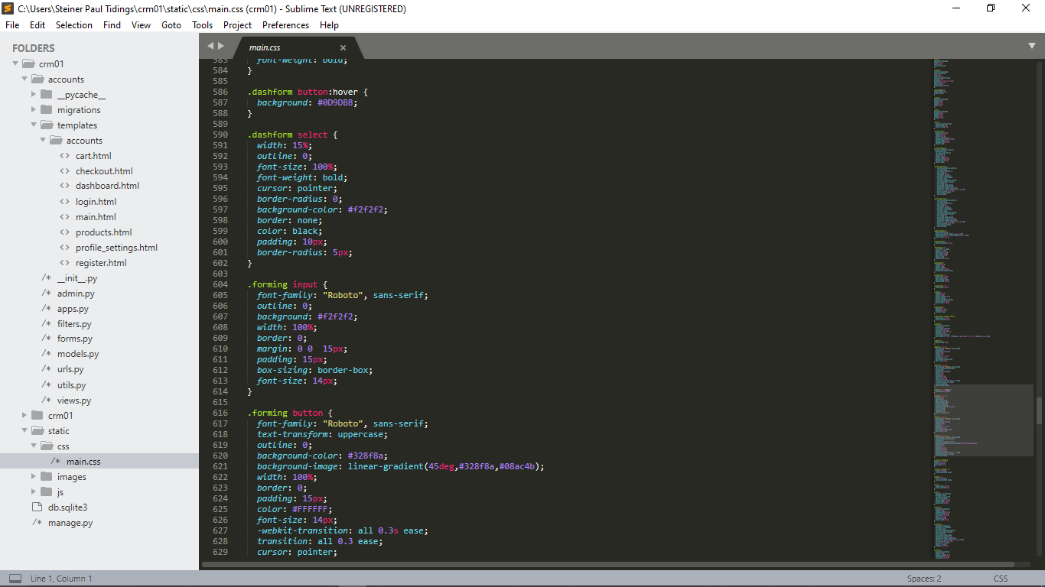

Figure 6.30

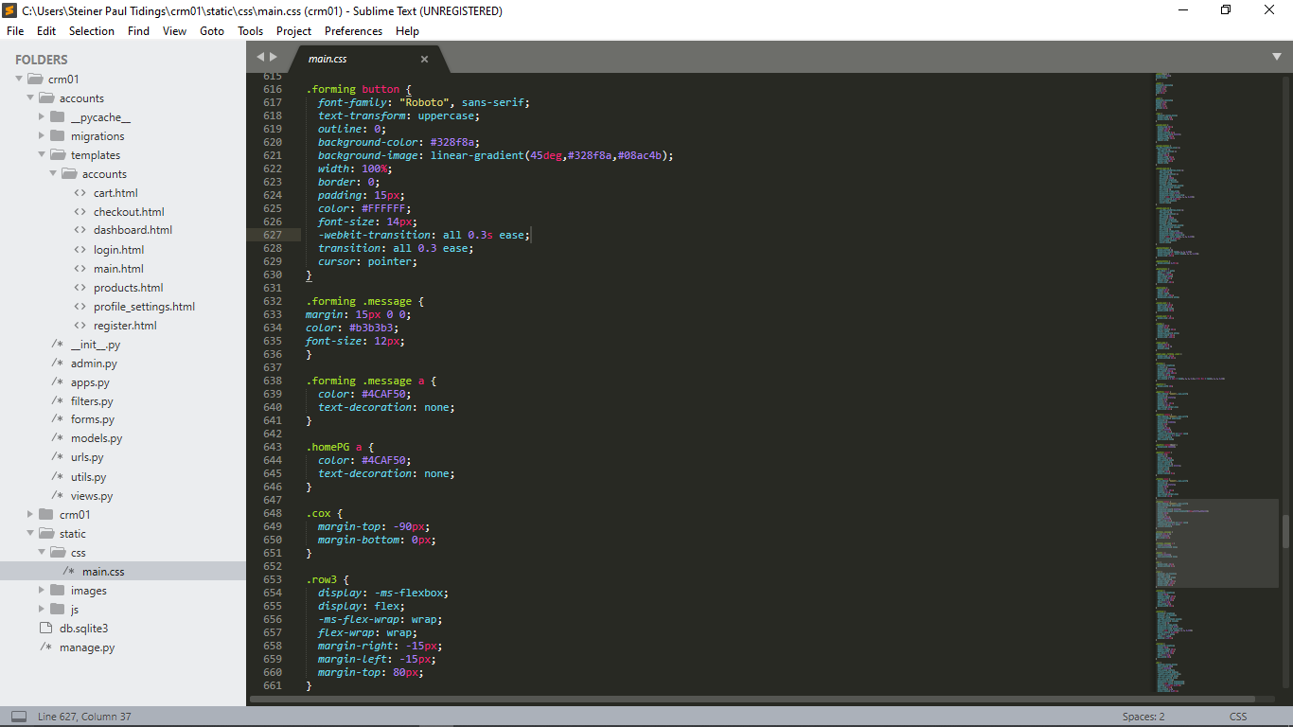

Figure 6.31

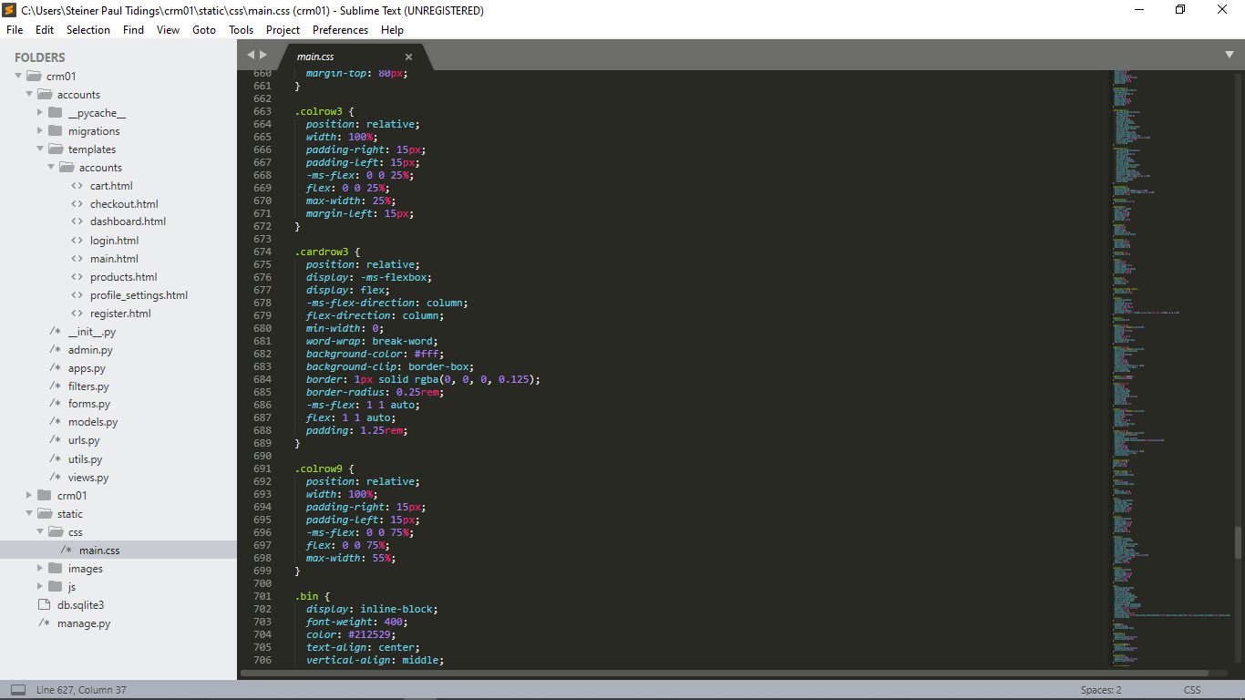

Figure 6.32

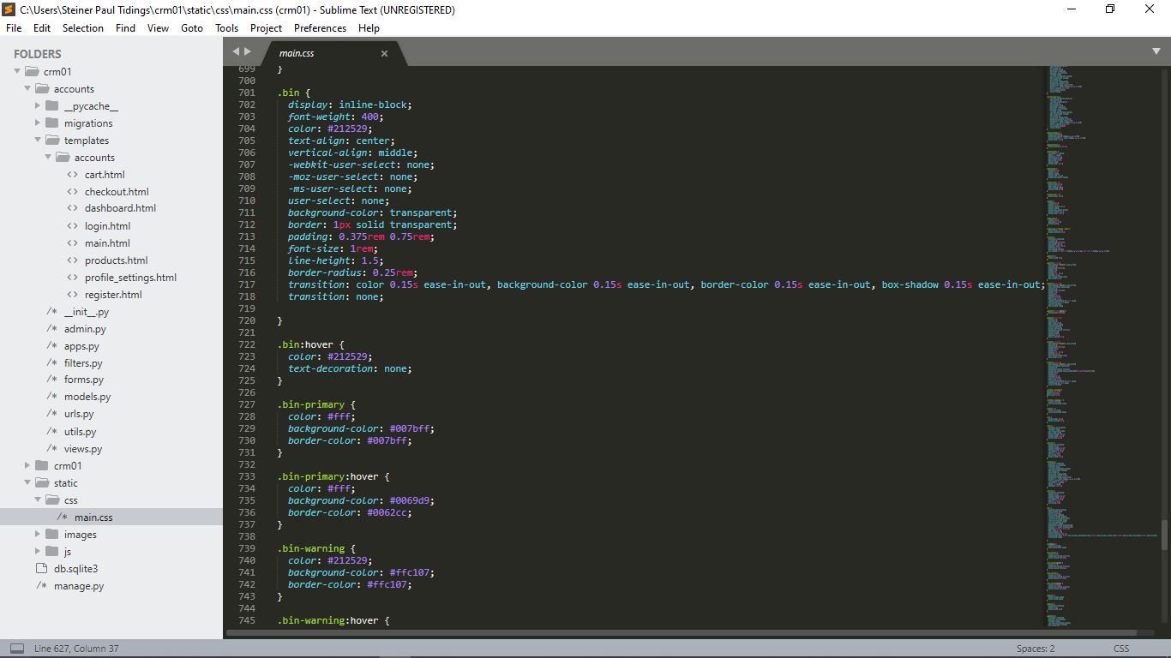

Figure 6.33

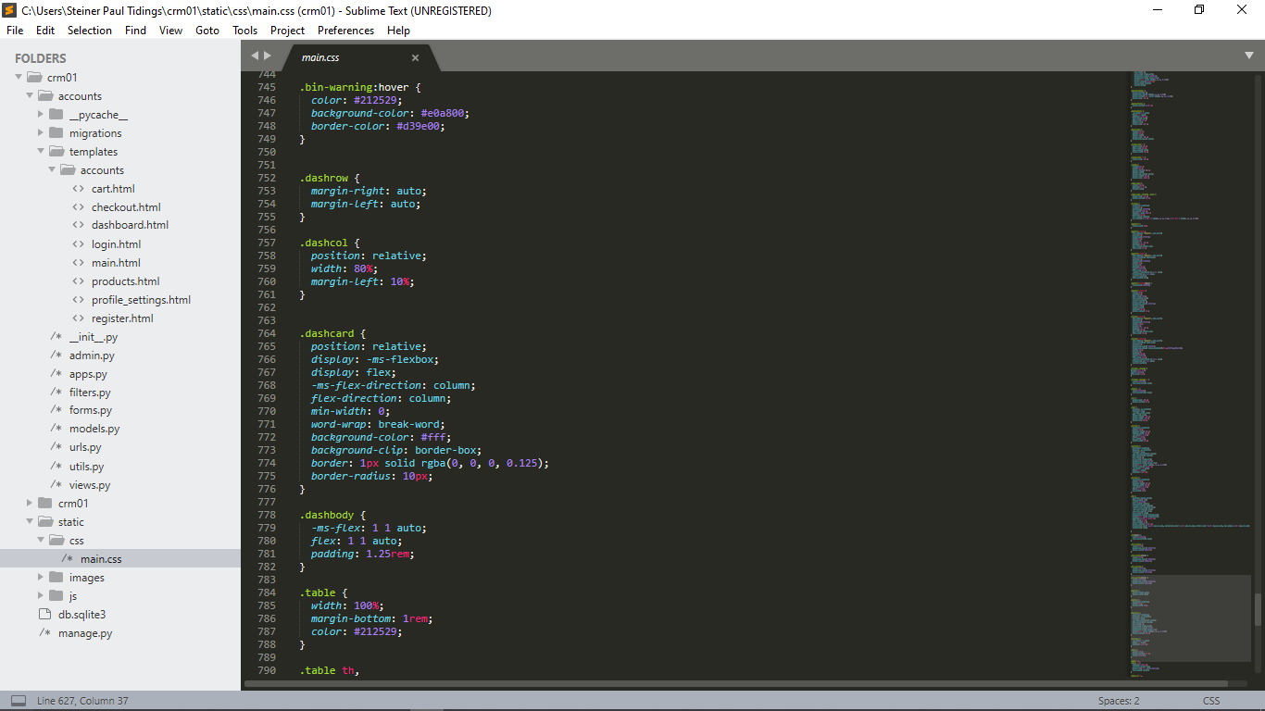

Figure 6.34

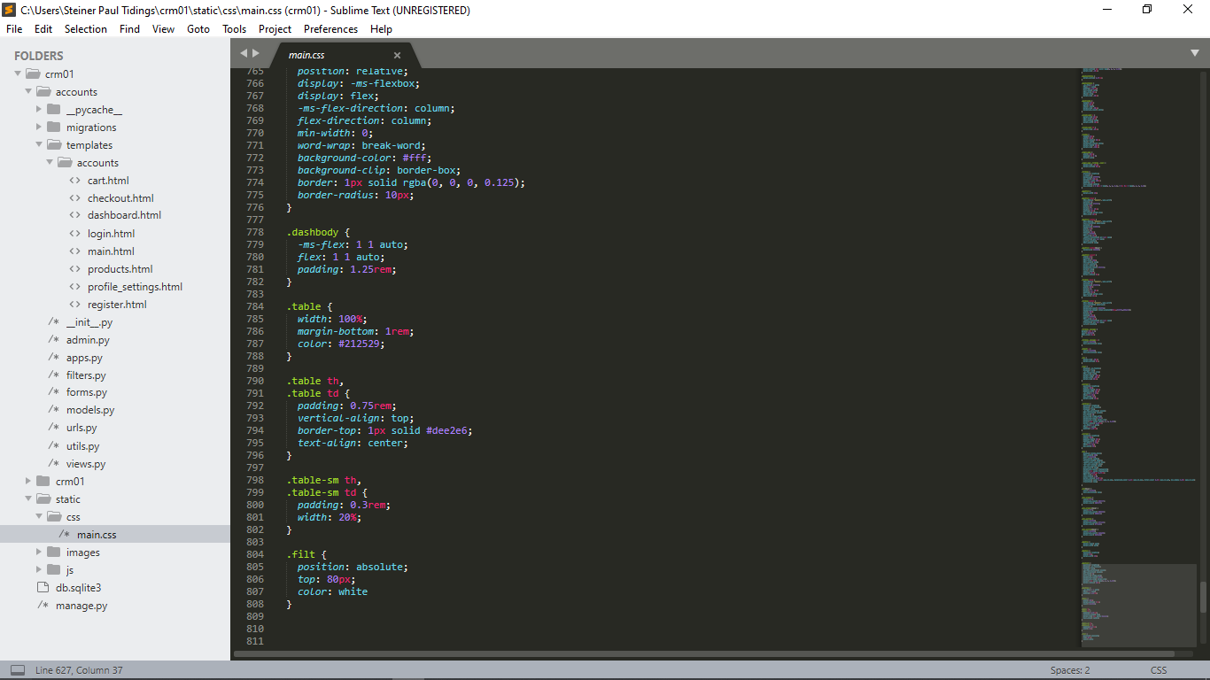

Figure 6.35

## JavaScript

### Cart.js

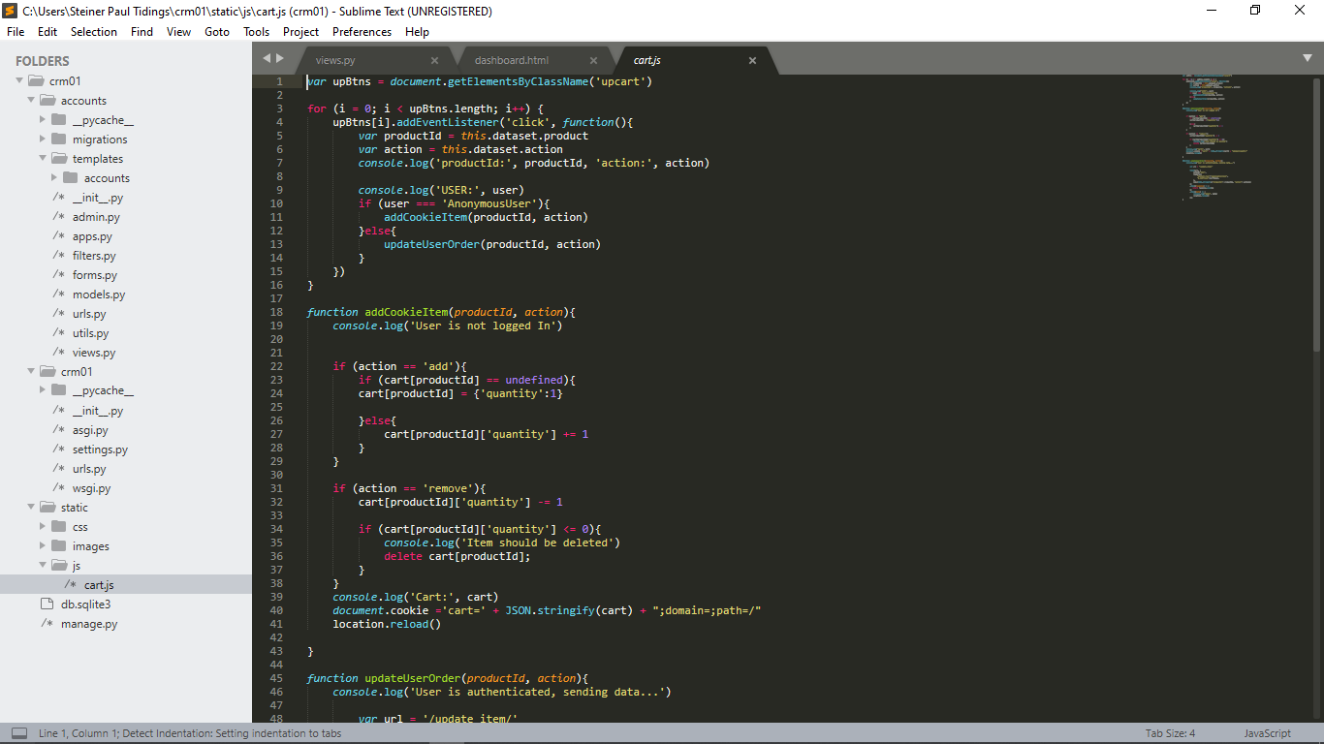

Figure 6.36

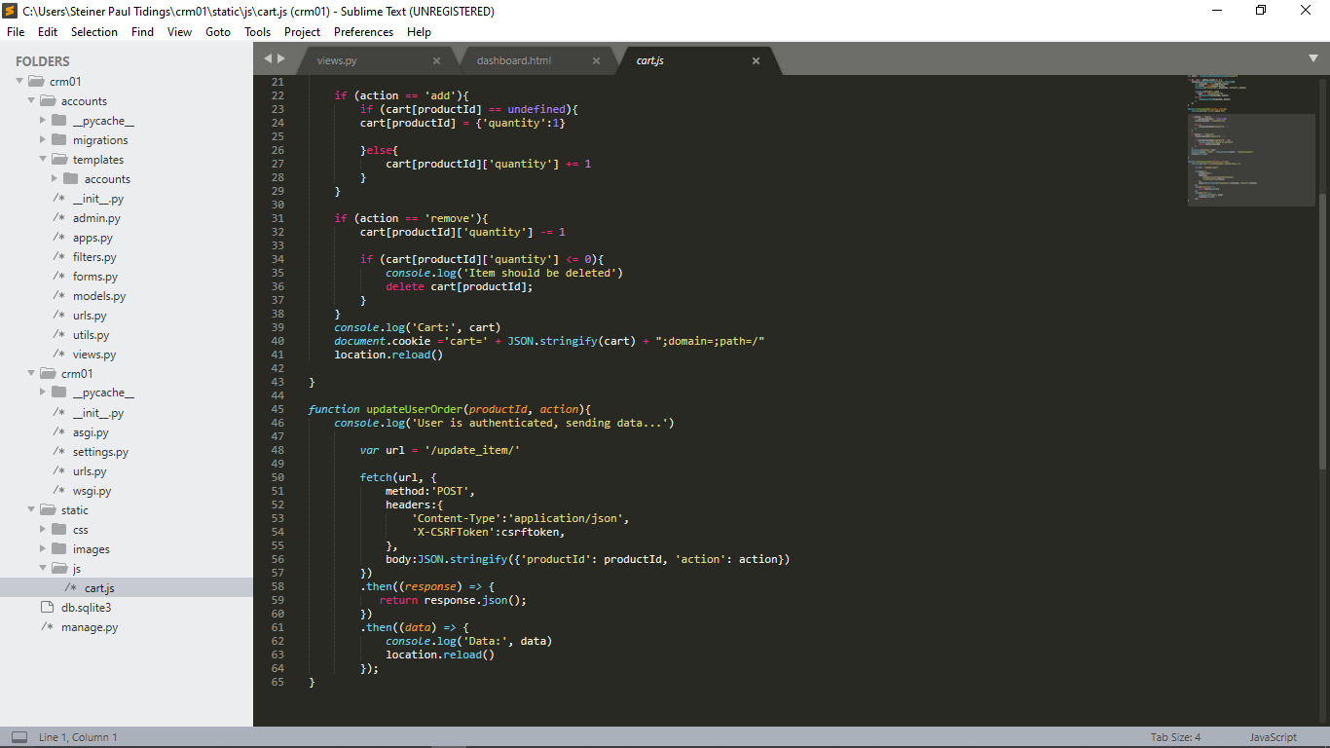

Figure 6.37

## Python programming language

### Admin.py

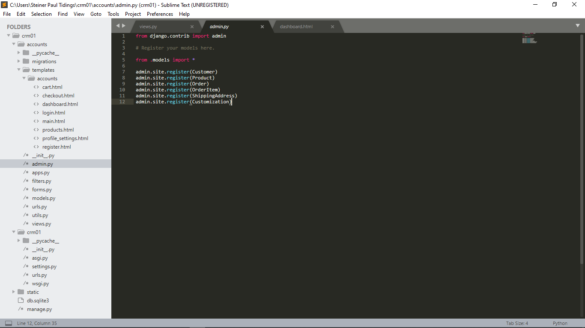

Figure 6.38

### Apps.py

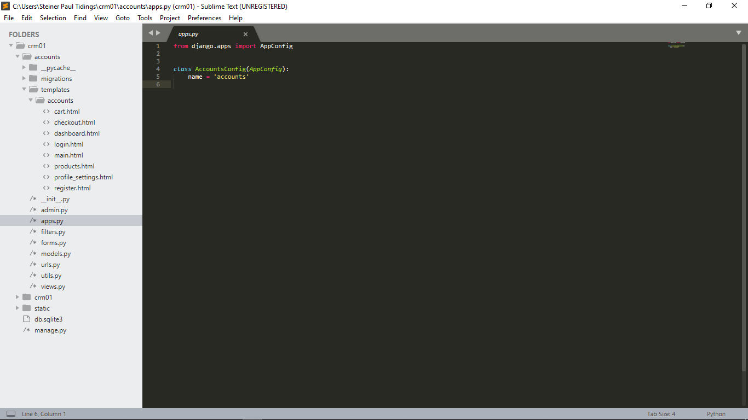

Figure 6.39

### filters.py

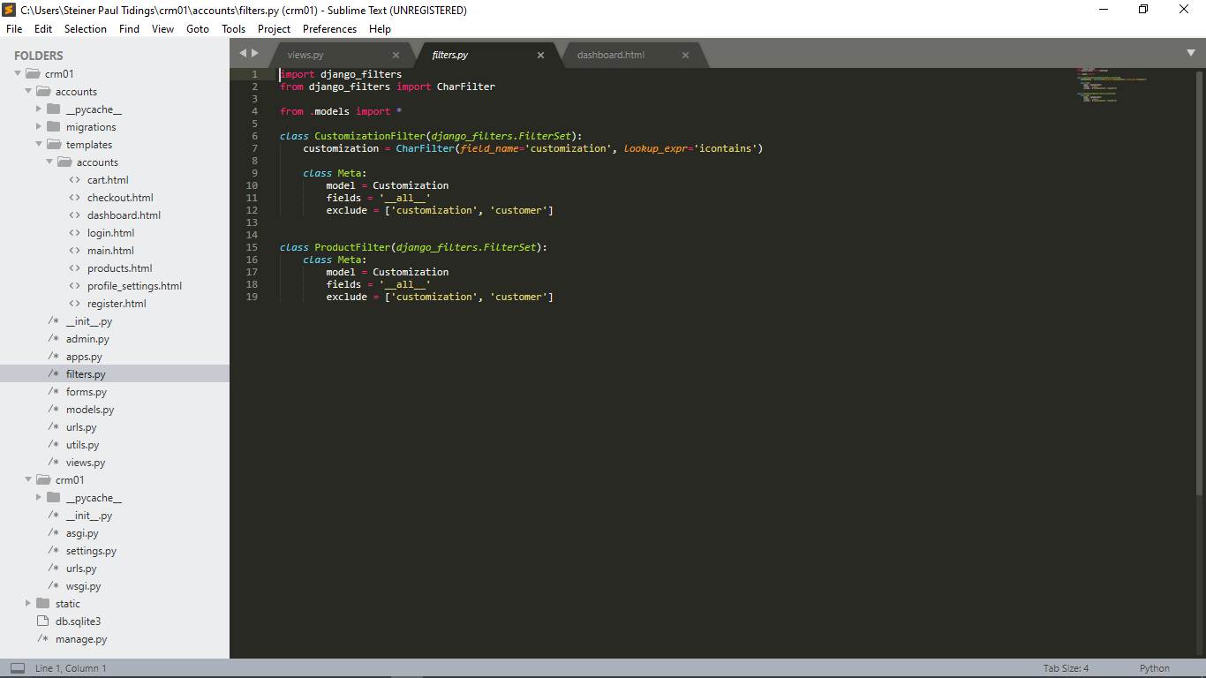

Figure 6.40

### forms.py

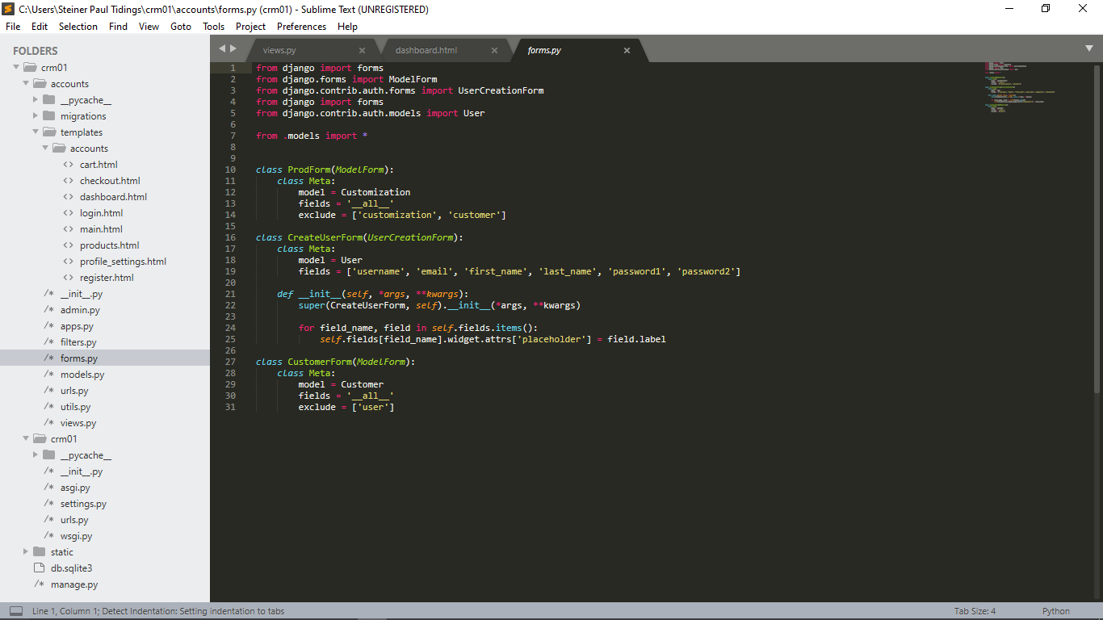

Figure 6.41

### urls.py

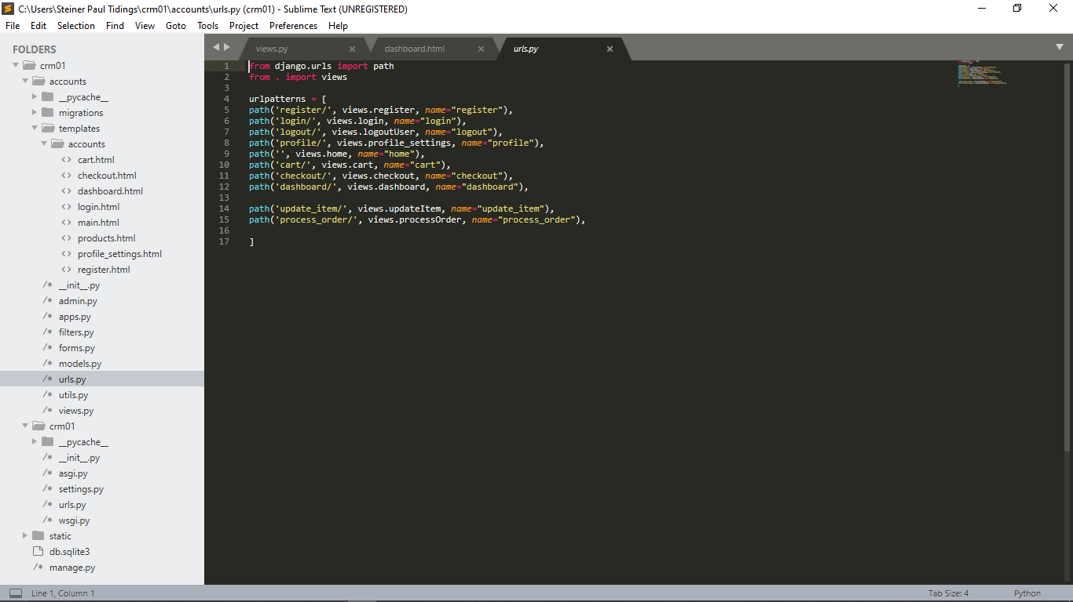

Figure 6.43

### Urls.py

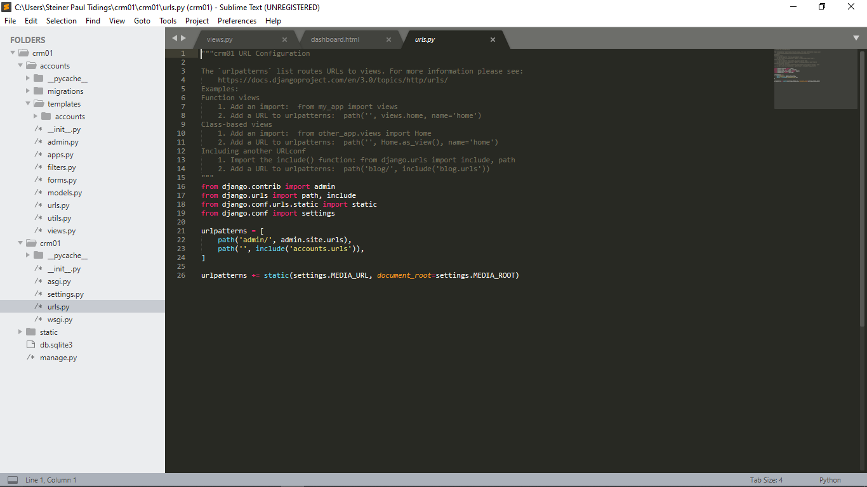

Figure 6.45

### models.py

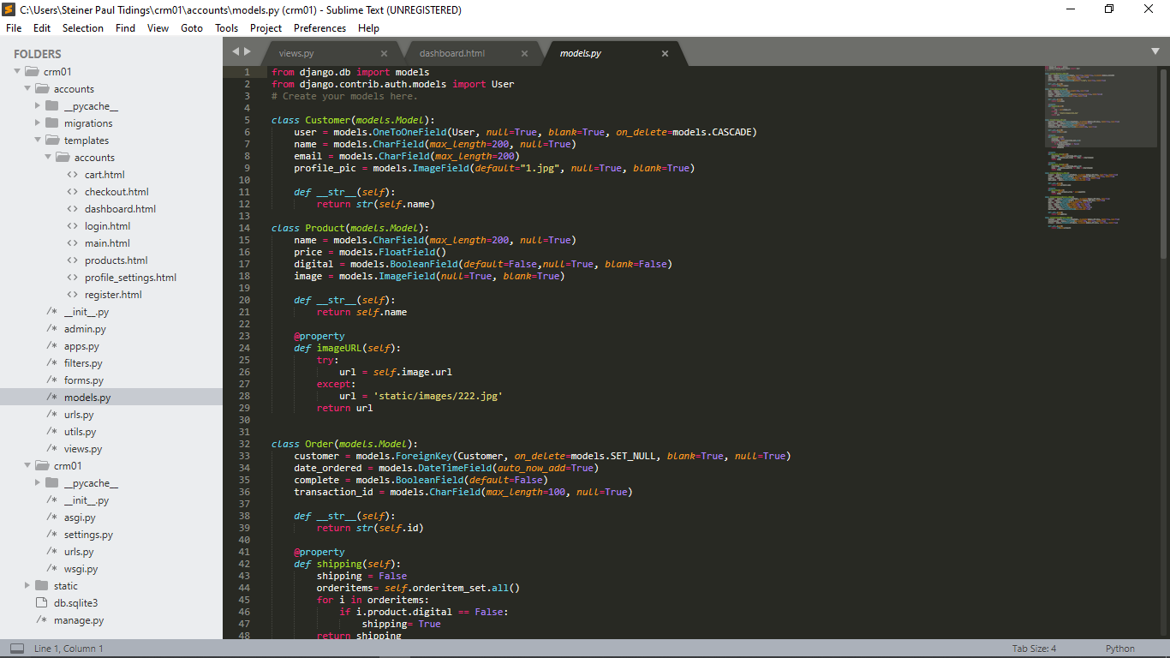

Figure 6.46

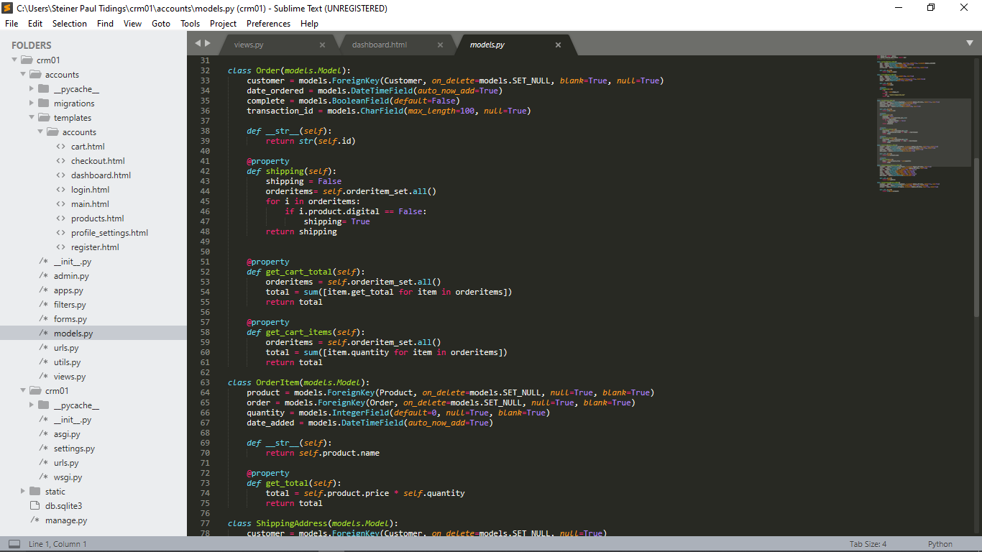

Figure 6.47

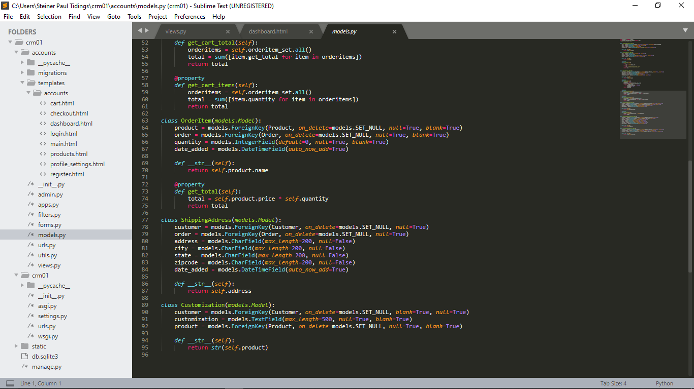

Figure 6.48

### Utils.py

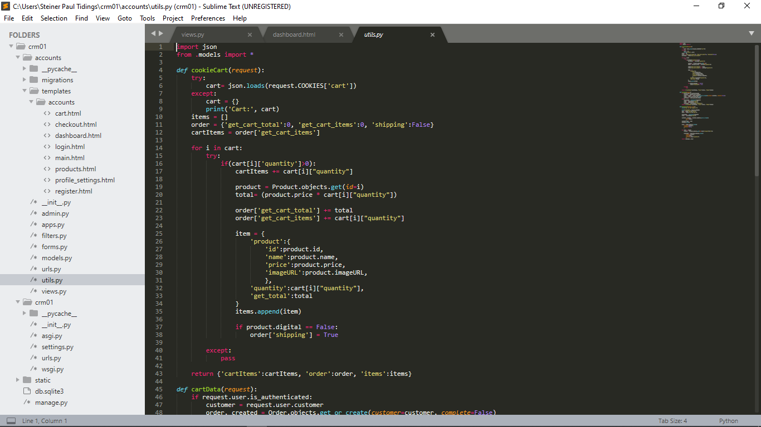

Figure 6.49

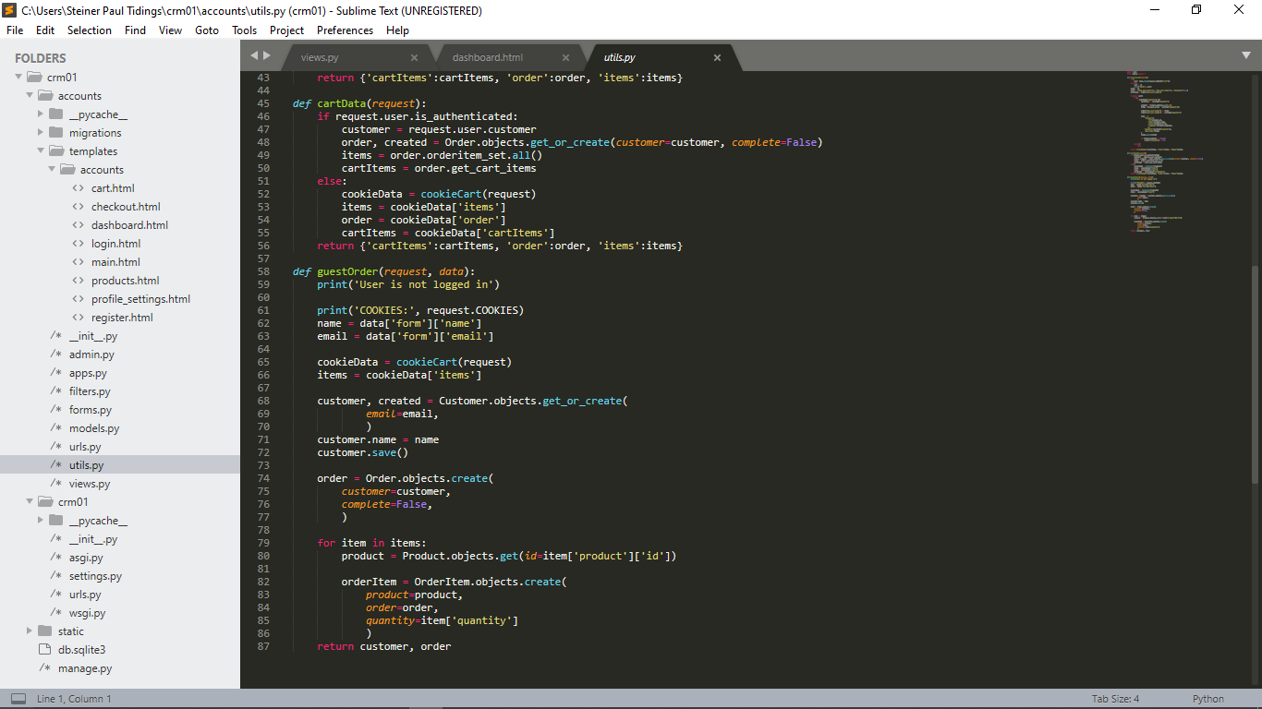

Figure 6.50

### views.py

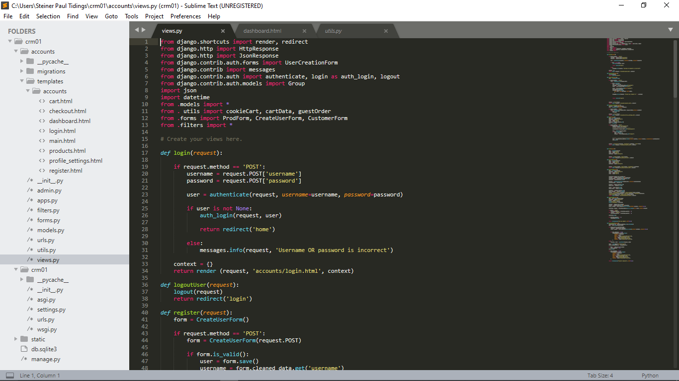

Figure 6.51

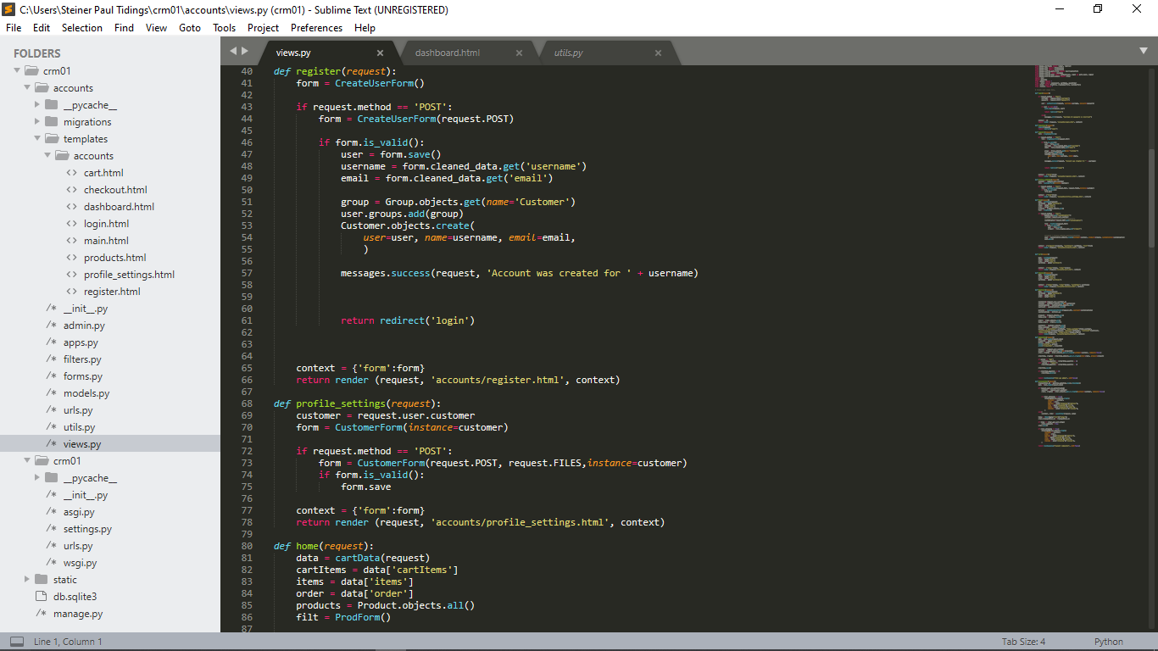

Figure 6.52

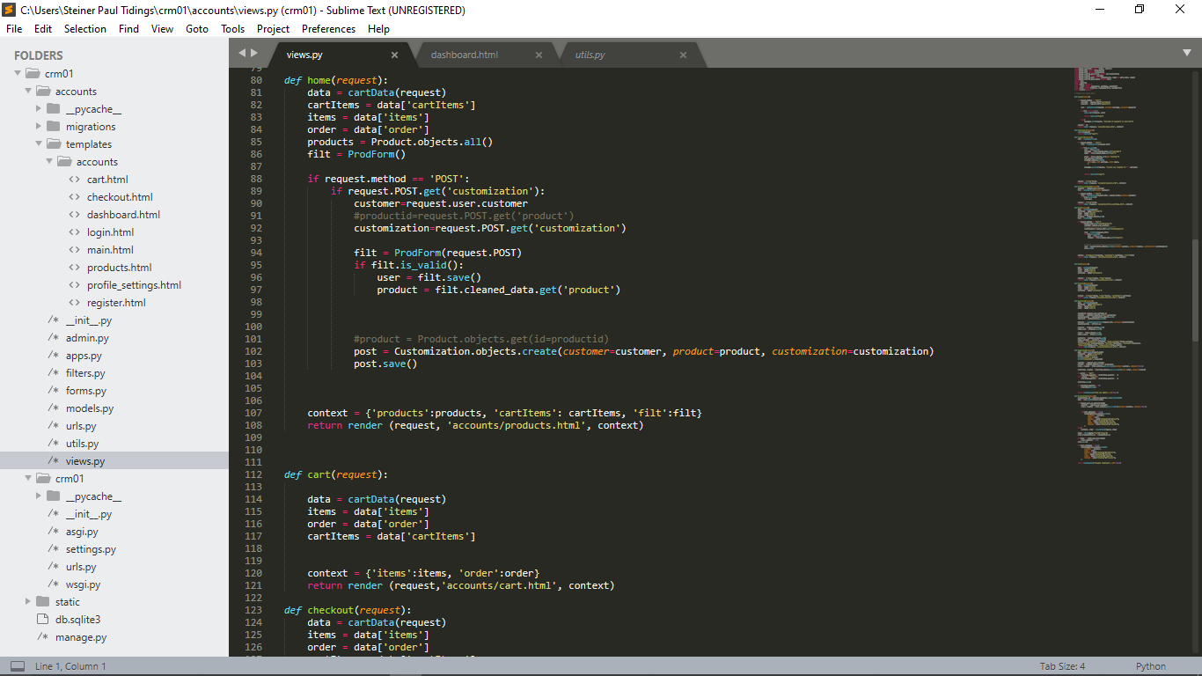

Figure 6.53

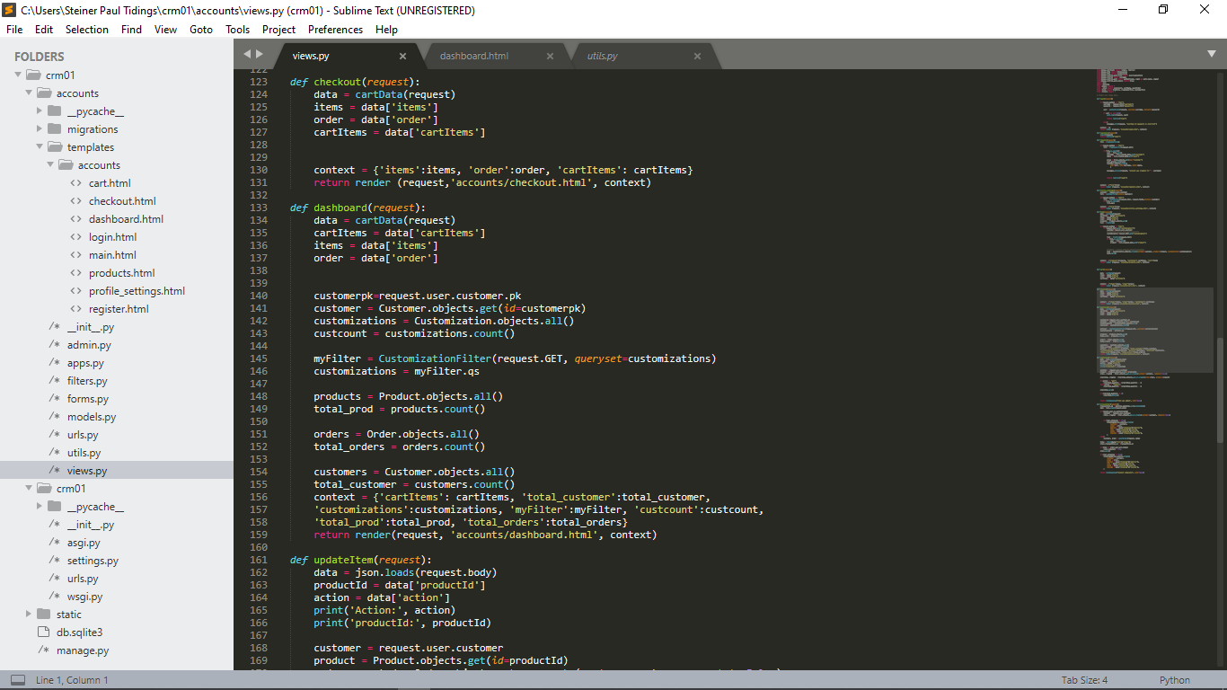

Figure 6.54

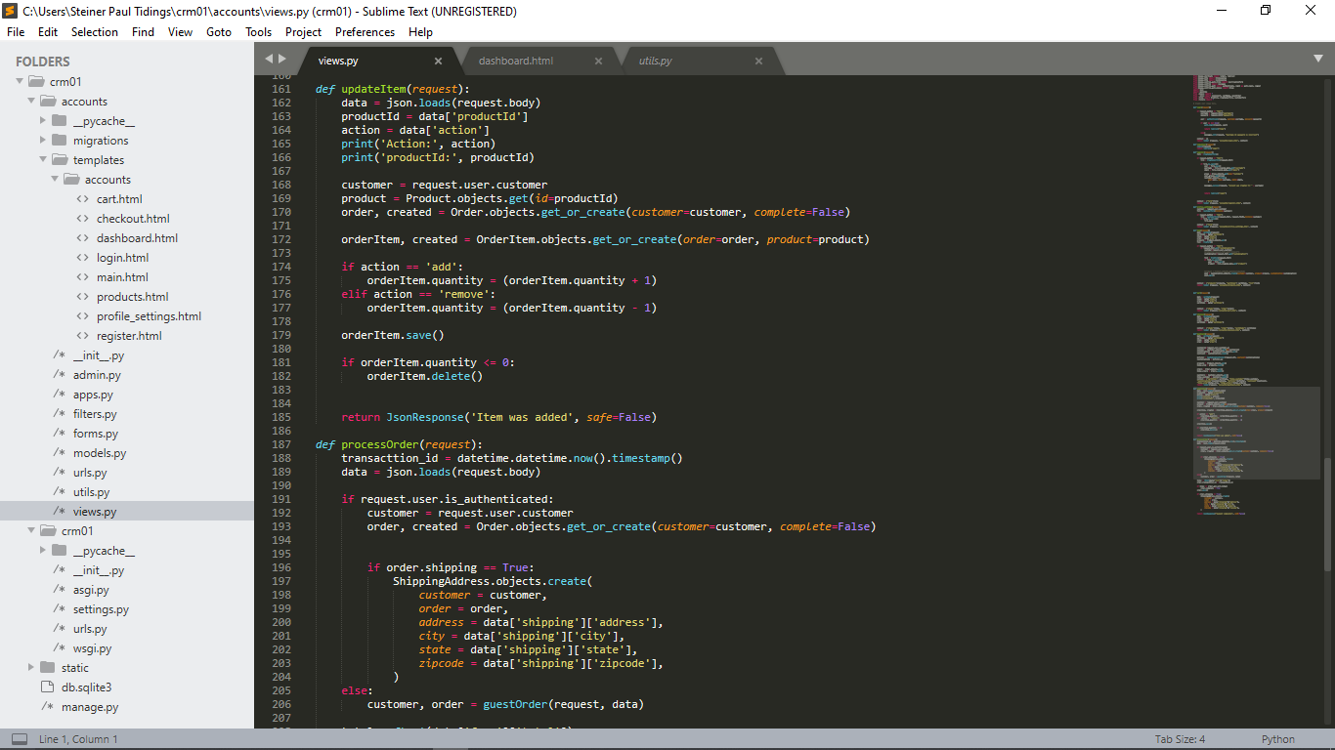

Figure 6.55

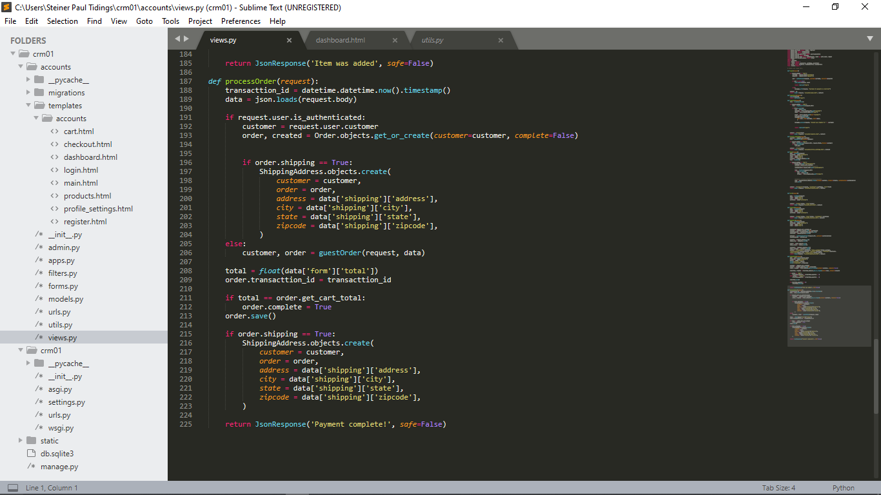

Figure 6.56

### wsgi.py

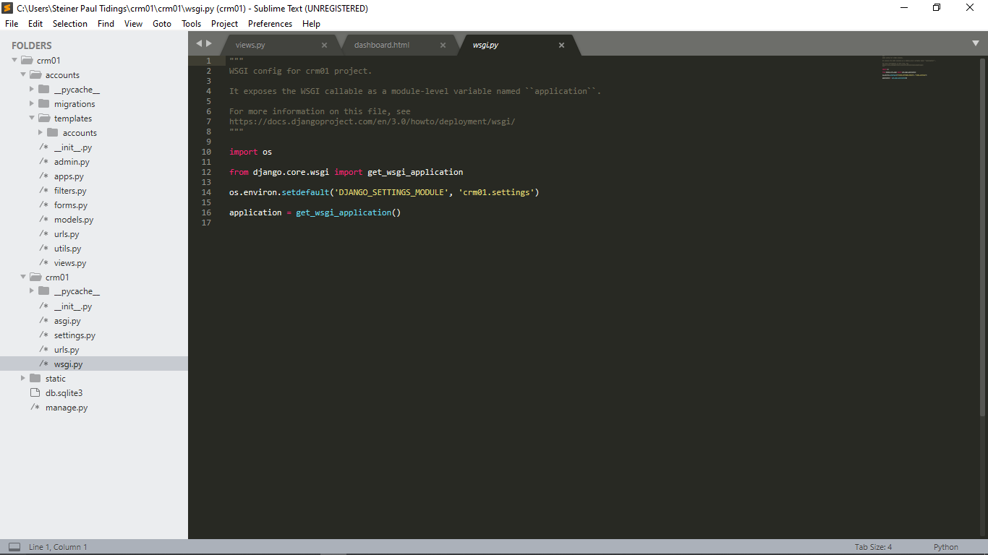

Figure 6.57

### asgi.py

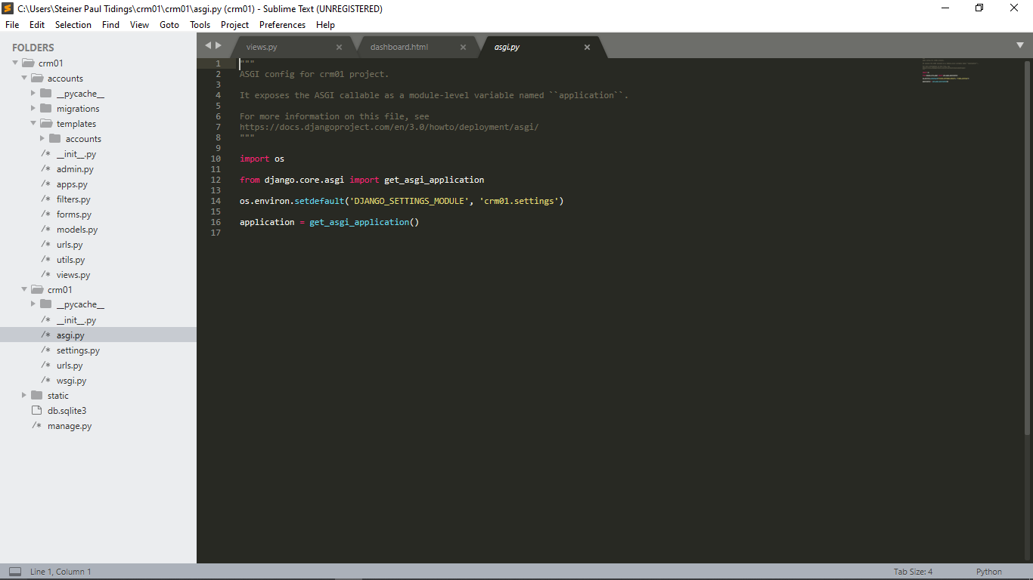

Figure 6.58

### settings.py

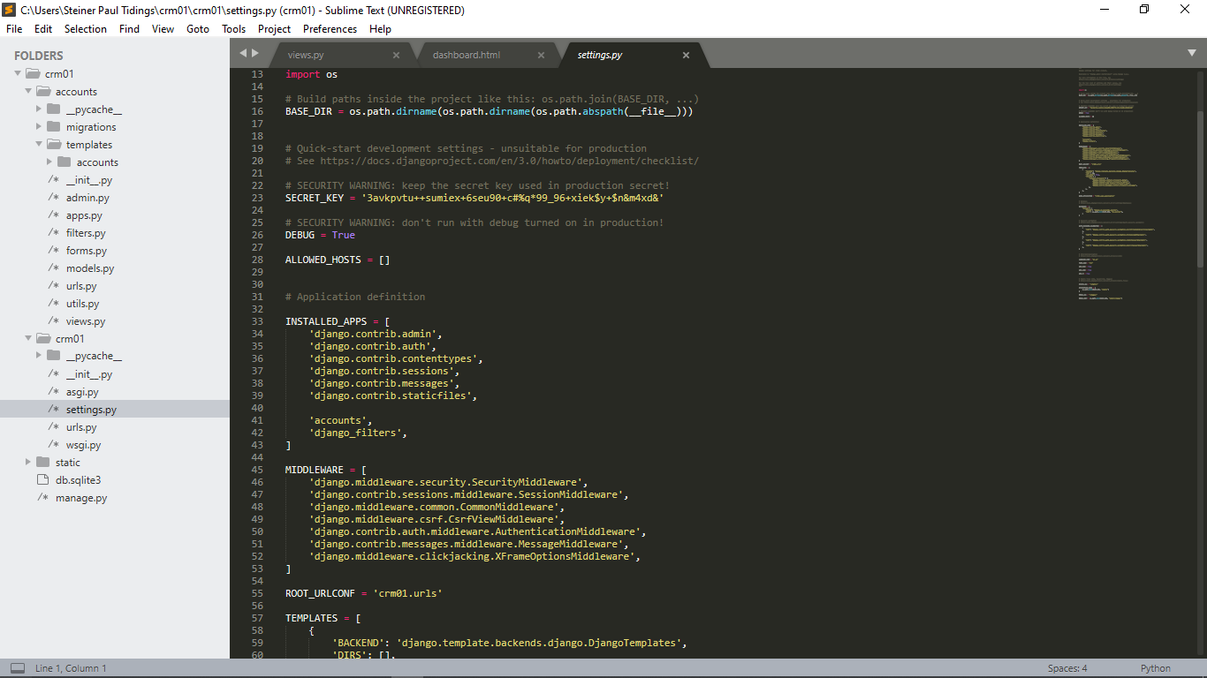

Figure 6.59

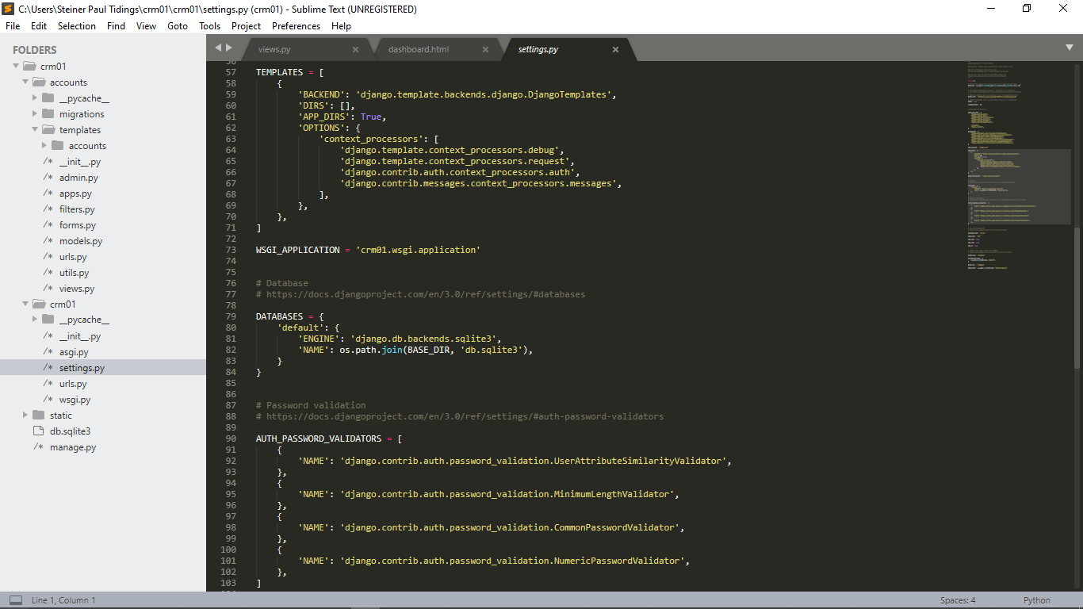

Figure 6.60

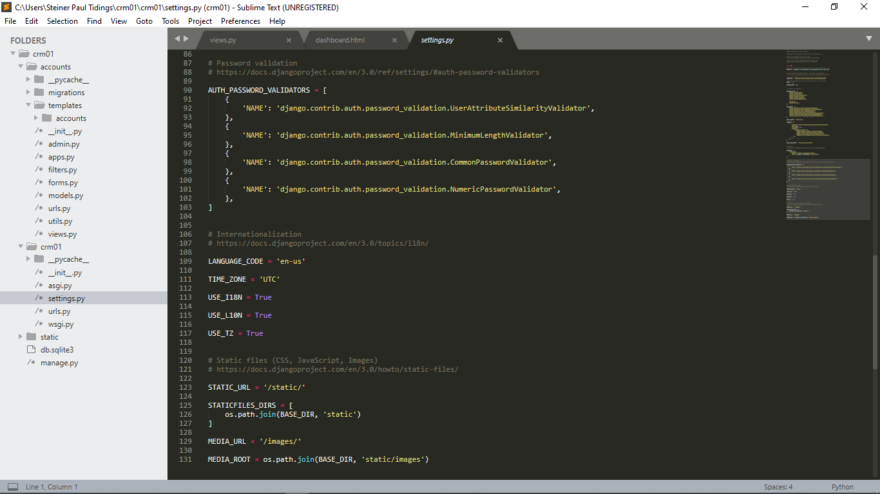

Figure 6.61